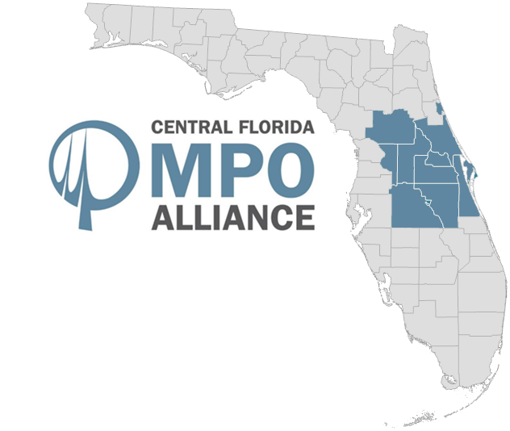
Regional Indicators
A Report on Transportation System Indicators for the Central Florida
MPO Alliance
December 2022
Table of Contents

CHAPTER 1 | EXECUTIVE SUMMARY
Methodology 2
Key Findings 2
About Us 4

CHAPTER 2 | AREA PROFILE
Population & Employment Trends 5
Visitation & Tourism 9
Regional Demographics 11
Land Use & Urbanization 14

CHAPTER 3 | REGIONAL ASSETS
Land Assets 17
Air Assets 17
Sea Assets 33
Space Assets 33

CHAPTER 4 | MEGA TRENDS
Safety Concerns 34
Air Quality 34
Transportation System Usage, Reliability & Congestion 41
E-Commerce & Remote Work 54
Electric Vehicles & Fuel Consumption 56
Autonomous Vehicles 61

APPENDICES
A1 – Road User Statistics 64
A2 – Highway Statistics 66
A3 – System Performance Measures 68
A4 – Source Documentation 70

1 | Executive Summary

Transportation is a critical part of our lives. The quality of life and the economic vitality of our communities depend on an individual’s access to work, education, health services and other destinations. The condition of our roads, walkways, transit, runways, and other transportation features directly affects the well-being of our businesses, residents, and visitors alike.

The Central Florida Metropolitan Planning Organization Alliance (CFMPOA) is a coalition of Metropolitan Planning Organizations (MPOs) and Transportation Planning Organizations (TPOs) committed to addressing transportation challenges on a regional basis. The purpose of this report is to provide an overview of the transportation system within the CFMPOA region and how they are affected by conditions such as the economy, population growth, technology, travel behavior, and funding. The goal is to identify key factors and emerging trends that impact Central Florida’s transportation needs.

Methodology
This report was originally prepared by MetroPlan Orlando to collect and maintain data on critical transportation indicators to inform future policy decisions. In 2022, the report was updated to include additional data sources and map layers, including information compiled in the Florida Department of Transportation Source Book.

The Regional Indicators report includes the latest data and available information at the time of publication for the various indicators used to measure transportation system activity over a five-year-to-ten-year period.

Data is provided by several national, state, and local agencies, including the Federal Highway Administration, the U.S. Census Bureau, the U.S. Department of Labor Statistics, the Florida Department of Transportation, the Florida Department of Highway Safety and Motor Vehicles, the Florida Department of Environmental Protection, the University of Florida Bureau of Business and Economic Research, and numerous others as described in the source documentation section of the report.

About Us
The Central Florida Metropolitan Planning Organization (MPO) Alliance is a coalition of transportation and government organizations committed to addressing transportation challenges on a regional basis. The group is made up of representatives from the ten-county Central Florida region, including portions of Flagler County.

The MPO Alliance has a policy board of eighteen members, three from each of the six member organizations. Representatives from the Florida Department of Transportation also participate. The group meets quarterly and operates on the basis of consensus, and staff support is provided by MetroPlan Orlando. The Central Florida MPO Alliance has established goals and is seeking to maximize all opportunities presented by a regional transportation forum.
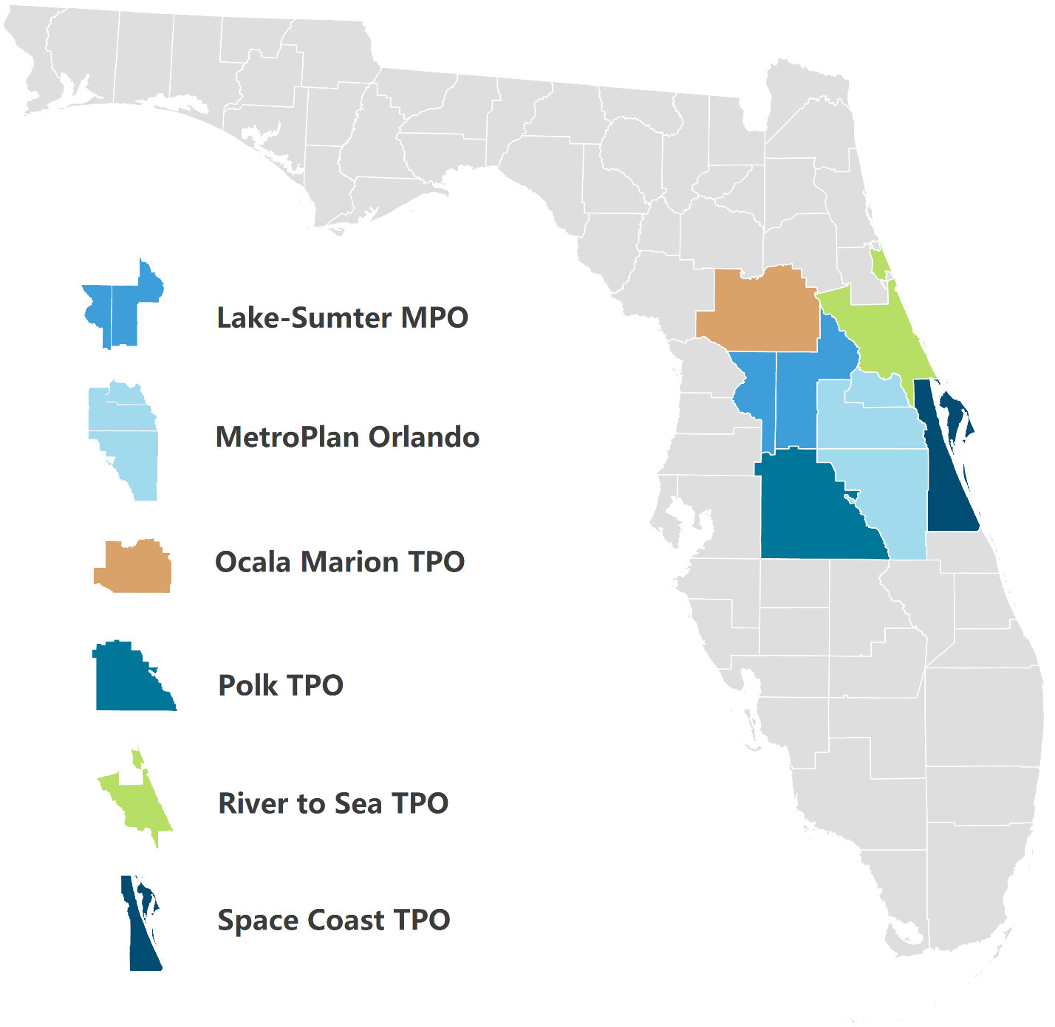
MPO/TPO Staff Contact Information

Lake-Sumter MPO Polk TPO
(Lake and Sumter Counties) (Polk County)
Michael Woods, Executive Director Parag Agrawal, Executive Director
1616 South 14th Street 330 W. Church Street
Leesburg, Florida 34748 Bartow, Florida 33830
(352) 315-0170 (863) 534-6486
www.lakesumtermpo.com www.polktpo.com

MetroPlan Orlando River to Sea TPO
(Orange, Osceola and Seminole Counties) (Volusia County, parts of Flagler County)
Gary Huttmann, Executive Director Colleen Nicoulin, Executive Director
250 South Orange Avenue, Suite 200 1 Deuce Court., Suite 100
Orlando, Florida 32801 Daytona Beach, Florida 32124
(407) 481-5672 (386) 226-0422
www.metroplanorlando.com www.r2ctpo.org

Ocala/Marion TPO Space Coast TPO
(Marion County) (Brevard County)
Rob Balmes, Director Georganna Gillette, Executive Director
121 SE Watula Avenue 2725 Judge Fran Jamieson Way, Bldg. B, 82
Ocala, Florida 34471 Viera, Florida 32940
(352) 629-8297 (321) 690-6890
www.ocalamariontpo.org www.spacecoasttpo.com

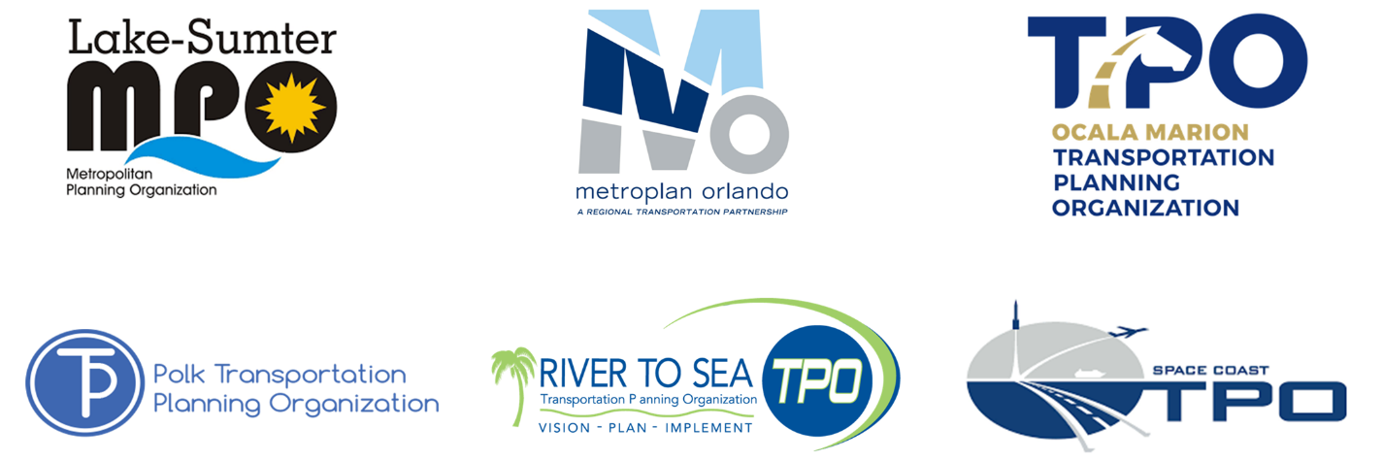

2 | Area Profile

Section Outline
2.1: Population & Employment Trends
2.2: Visitation & Tourism
2.3: Regional Demographics
2.4: Land Use & Urbanization

2.1 | Population & Employment Trends

Population
The table below shows population growth trends for the ten counties and each of the six TPO’s included in the Central Florida MPO Alliance region as provided by the U.S. Census Bureau.¹ Additionally, 2045 population projections from the University of Florida Bureau of Economic and Business Research (BEBR) are provided.² Additional tables are available in Appendix 1.

County Population | 2018 | 2019 | 2020 | 2021 | % Growth | 2045 | % Growth
 |  |  |  |  | 2018-21 |  | 2021-45
Brevard County | 594,978 | 601,024 | 608,459 | 616,628 | 3.6% | 739,100 | 19.9%
Flagler County* | 112,415 | 115,481 | 118,451 | 120,932 | 7.6% | 165,200 | 36.6%
Lake County | 357,086 | 366,941 | 375,492 | 395,804 | 10.8% | 587,900 | 48.5%
Marion County | 359,630 | 365,997 | 373,513 | 385,915 | 7.3% | 472,700 | 22.5%
Orange County | 1,383,657 | 1,395,371 | 1,429,899 | 1,422,746 | 2.8% | 1,968,996 | 38.4%
Osceola County | 367,359 | 374,170 | 385,315 | 403,282 | 9.8% | 657,100 | 62.9%
Polk County | 707,095 | 724,976 | 744,552 | 753,320 | 6.5% | 1,019,500 | 35.3%
Seminole County | 468,195 | 471,791 | 474,171 | 470,093 | 0.4% | 567,300 | 20.7%
Sumter County | 129,351 | 133,772 | 139,018 | 135,638 | 4.9% | 219,600 | 61.9%
Volusia County | 547,117 | 554,065 | 561,497 | 564,412 | 3.2% | 674,200 | 19.5%
CFMPOA Region | 5,026,883 | 5,103,588 | 5,210,367 | 5,268,770 | 4.8% | 7,071,596 | 34.2%
* Portions of Flagler County are not included in the CFMPOA Alliance region. This table includes all of Flagler County
Source(s): U.S. Census Bureau (2018-2021); UF BEBR (2045)
TPO Population | 2018 | 2019 | 2020 | 2021 | % Growth | 2045 | % Growth
 |  |  |  |  | 2018-21 |  | 2021-45
Lake-Sumter MPO | 486,437 | 500,713 | 514,510 | 531,442 | 9.3% | 807,500 | 51.9%
MetroPlan Orlando | 2,219,211 | 2,241,332 | 2,289,385 | 2,296,121 | 3.5% | 3,193,396 | 39.1%
Ocala Marion TPO | 359,630 | 365,997 | 373,513 | 385,915 | 7.3% | 472,700 | 22.5%
Polk TPO | 707,095 | 724,976 | 744,552 | 753,320 | 6.5% | 1,019,500 | 35.3%
River to Sea TPO* | 659,532 | 669,546 | 679,948 | 685,344 | 3.9% | 839,400 | 22.5%
Space Coast TPO | 594,978 | 601,024 | 608,459 | 616,628 | 3.6% | 739,100 | 19.9%
* Portions of Flagler County are not included in the CFMPOA Alliance region. This table includes all of Flagler County
Source(s): U.S. Census Bureau (2018-2021); UF BEBR (2045)

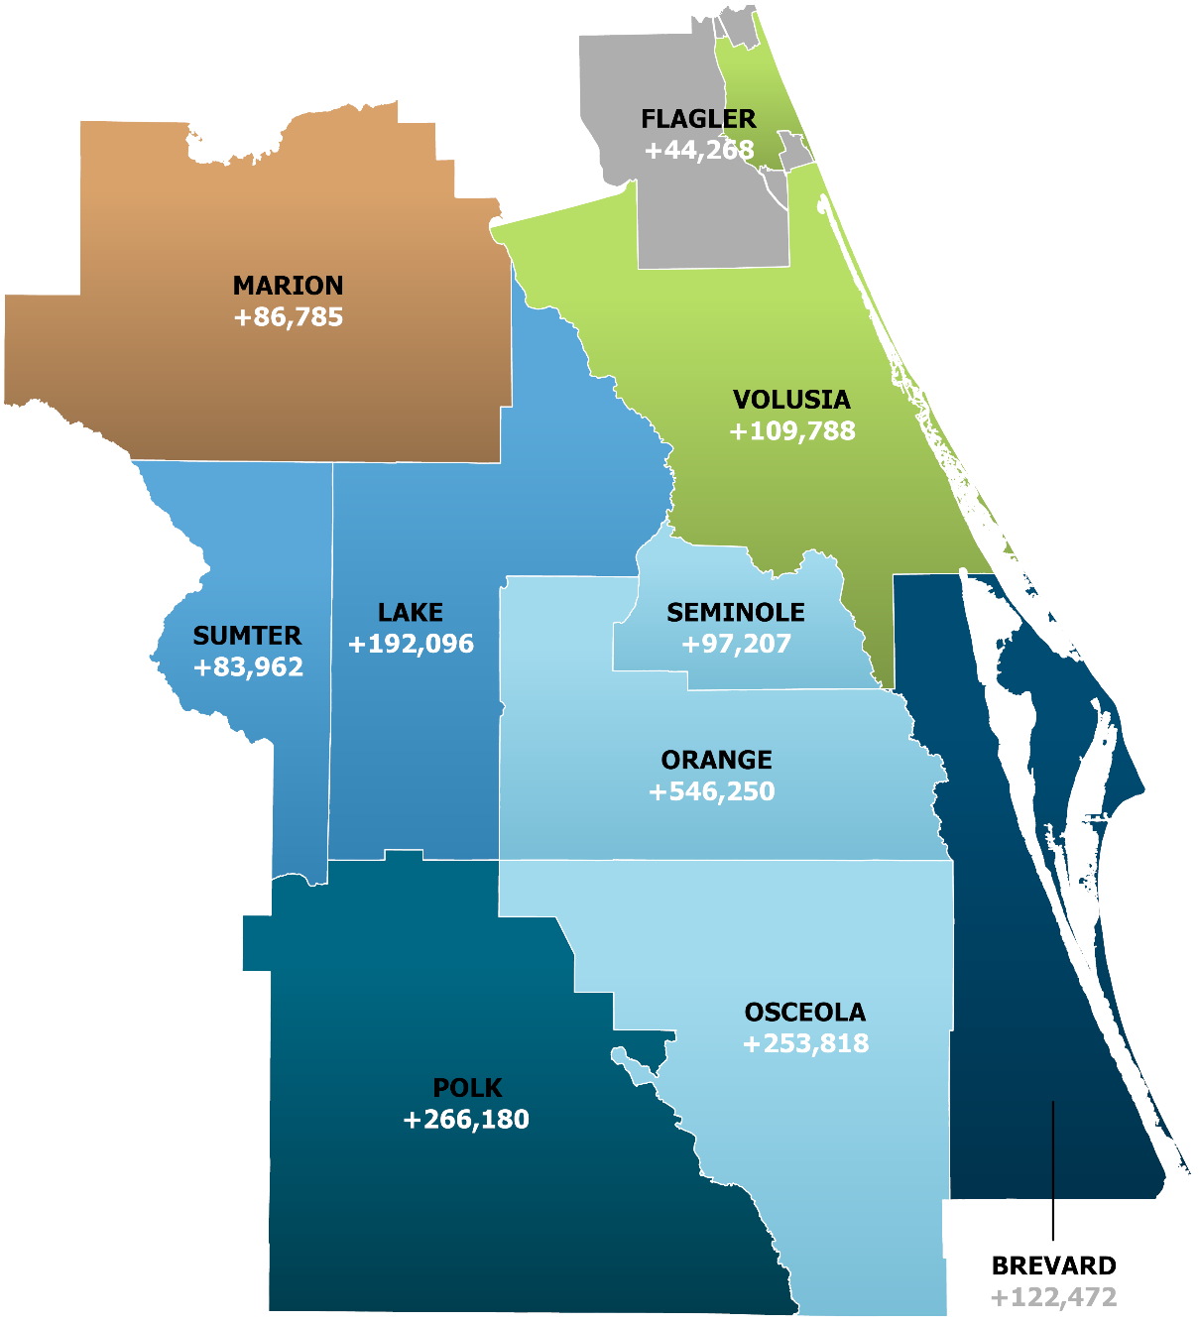
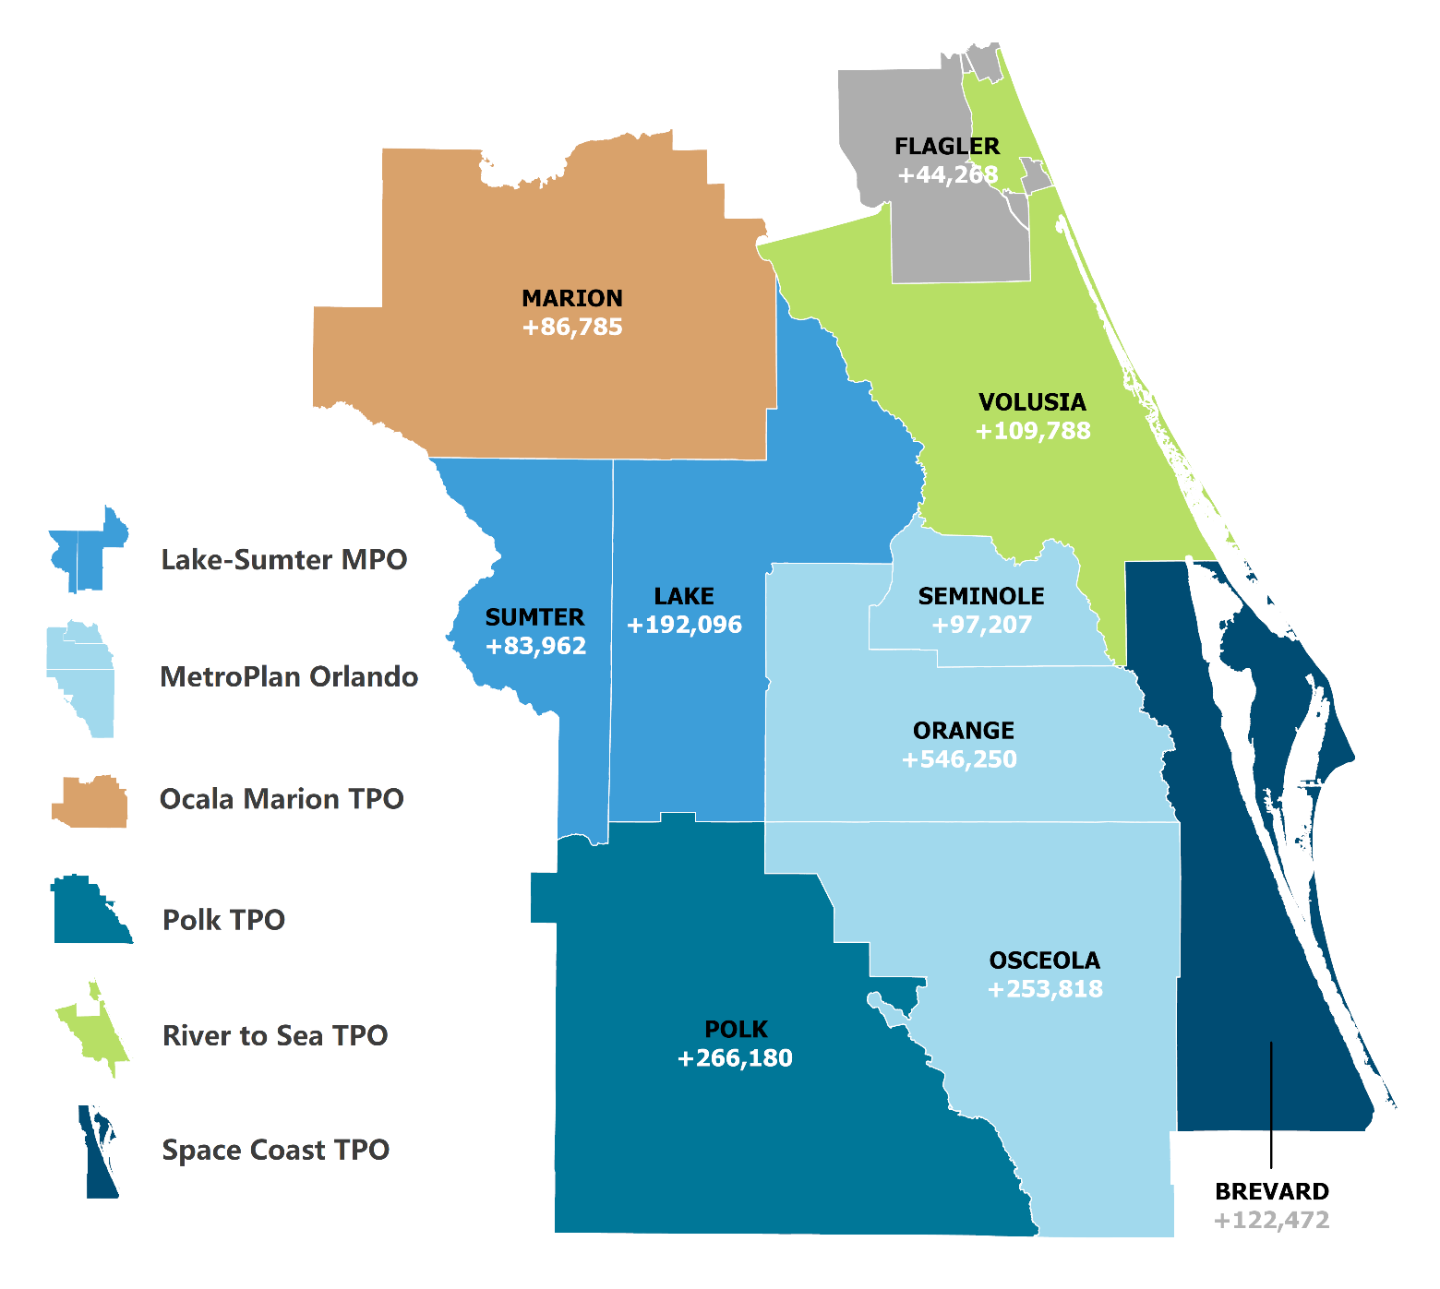
Projected Population Growth
by County, 2021-2045

UF BEBR

Employment
The tables and chart below show total employed individuals and the unemployment rate (depicted as “U. Rate”) for the ten counties and each of the six TPO’s included in the MPO Alliance region from 2018 to 2021, as provided by the U.S. Bureau of Labor Statistics.³ The chart shows the Central Florida MPO Alliance region unemployment rate from 2013 to 2021.

County Employment | 2018 |  | 2019 |  | 2020 |  | 2021
 | Employed | U. Rate | Employed | U. Rate | Employed | U. Rate | Employed | U. Rate
Brevard County | 264,555 | 3.6% | 272,198 | 3.3% | 261,302 | 7.2% | 277,951 | 4.0%
Flagler County* | 44,337 | 4.2% | 45,471 | 3.9% | 43,263 | 8.1% | 46,067 | 4.6%
Lake County | 148,689 | 3.7% | 155,121 | 3.3% | 142,000 | 9.4% | 152,035 | 4.7%
Marion County | 128,740 | 4.5% | 132,637 | 3.9% | 128,343 | 7.6% | 135,009 | 4.9%
Orange County | 715,936 | 3.3% | 730,279 | 3.0% | 656,788 | 11.5% | 702,684 | 5.2%
Osceola County | 172,446 | 3.8% | 177,876 | 3.4% | 162,828 | 14.4% | 174,170 | 6.3%
Polk County | 283,912 | 4.3% | 292,210 | 3.8% | 288,447 | 9.8% | 311,005 | 5.4%
Seminole County | 239,979 | 3.3% | 244,386 | 3.0% | 219,095 | 7.8% | 234,590 | 4.1%
Sumter County | 29,435 | 5.3% | 30,789 | 4.8% | 29,876 | 8.5% | 32,790 | 5.3%
Volusia County | 241,060 | 3.9% | 242,915 | 3.6% | 228,265 | 8.2% | 243,303 | 4.6%
CFMPOA Region | 2,269,089 | 3.7% | 2,323,882 | 3.3% | 2,160,207 | 9.8% | 2,309,604 | 4.9%
* Portions of Flagler County are not included in the CFMPOA Alliance region. This table includes all of Flagler County
Source(s): U.S. Bureau of Labor Statistics (2022)

TPO Employment | 2018 |  | 2019 |  | 2020 |  | 2021
 | Employed | U. Rate | Employed | U. Rate | Employed | U. Rate | Employed | U. Rate
Lake-Sumter MPO | 178,124 | 3.9% | 185,910 | 3.5% | 171,876 | 9.3% | 184,825 | 4.8%
MetroPlan Orlando | 1,128,361 | 3.4% | 1,152,541 | 3.1% | 1,038,711 | 11.2% | 1,111,444 | 5.1%
Ocala Marion TPO | 128,740 | 4.5% | 132,637 | 3.9% | 128,343 | 7.6% | 135,009 | 4.9%
Polk TPO | 283,912 | 4.3% | 292,210 | 3.8% | 288,447 | 9.8% | 311,005 | 5.4%
River to Sea TPO* | 285,397 | 3.9% | 288,386 | 3.6% | 271,528 | 8.2% | 289,370 | 4.6%
Space Coast TPO | 264,555 | 3.6% | 272,198 | 3.3% | 261,302 | 7.2% | 277,951 | 4.0%
* Portions of Flagler County are not included in the CFMPOA Alliance region. This table includes all of Flagler County
Source(s): U.S. Bureau of Labor Statistics (2022)
2.2 | Visitation & Tourism

This section of the Regional Indicators report provides data on visitation and tourism trends in the Central Florida MPO Alliance region.

Annual Visitors
The Central Florida MPO Alliance region has numerous attractions, ranging from beaches to some of the most-visited attractions in the world. The chart below shows a growing number of annual visitors to the Central Florida region through 2019, with a 53% decrease occurring in 2020 as a result of the COVID-19 pandemic. In 2021, visitor numbers rebounded to 2013 levels.⁴
Hotel Room Occupancy
The Central Florida MPO Alliance region has a very large service-related economy, and there are a large number of hotels and motels regionwide. The Table below shows the number of hotels and motels in the Central Florida MPO Alliance region from 2018 to 2021.⁵ License numbers for individual hotel rooms are not available via countywide search after 2017.

Hotel Rooms by County | 2013-14 | 2014-15 | 2015-16 | 2016-17 | % Growth
 |  |  |  |  | 2014-17
Brevard County | 9,312 | 9,277 | 9,195 | 9,335 | 0.2%
Flagler County* | N/A | N/A | N/A | N/A | N/A
Lake County | 2,995 | 2,995 | 2,731 | 2,752 | -8.1%
Marion County | 4,055 | 4,042 | 4,038 | 4,049 | -0.1%
Orange County | 86,571 | 87,662 | 87,717 | 89,333 | 3.2%
Osceola County | 25,115 | 24,435 | 24,155 | 24,365 | -3.0%
Polk County | 6,931 | 7,036 | 7,264 | 7,296 | 5.3%
Seminole County | 4,989 | 5,226 | 5,054 | 4,637 | -7.1%
Sumter County | 770 | 770 | 770 | 763 | -0.9%
Volusia County | 11,755 | 11,840 | 11,748 | 11,441 | -2.7%
CFMPOA Region | 152,493 | 153,283 | 152,672 | 153,971 | 1.0%
* Portions of Flagler County are not included in the CFMPOA Alliance region. This table includes all of Flagler County
Source(s): Florida Dept. of Business and Professional Regulation
Destinations
The map below depicts major destinations present in the Central Florida MPO Alliance region. Orange County, which is in the central portion of the region, is home to numerous theme park and entertainment attractions including Walt Disney World, Universal Orlando Resort, and the International Drive district. The Orange County Convention Center is also a major business destination. Along the east coast, the region boasts one of the largest ports in the U.S., Port Canaveral, as well as the Kennedy Space Center.

Other major destinations include Daytona International Speedway, historic town centers, world-famous beaches, and natural destinations including springs and national forests.
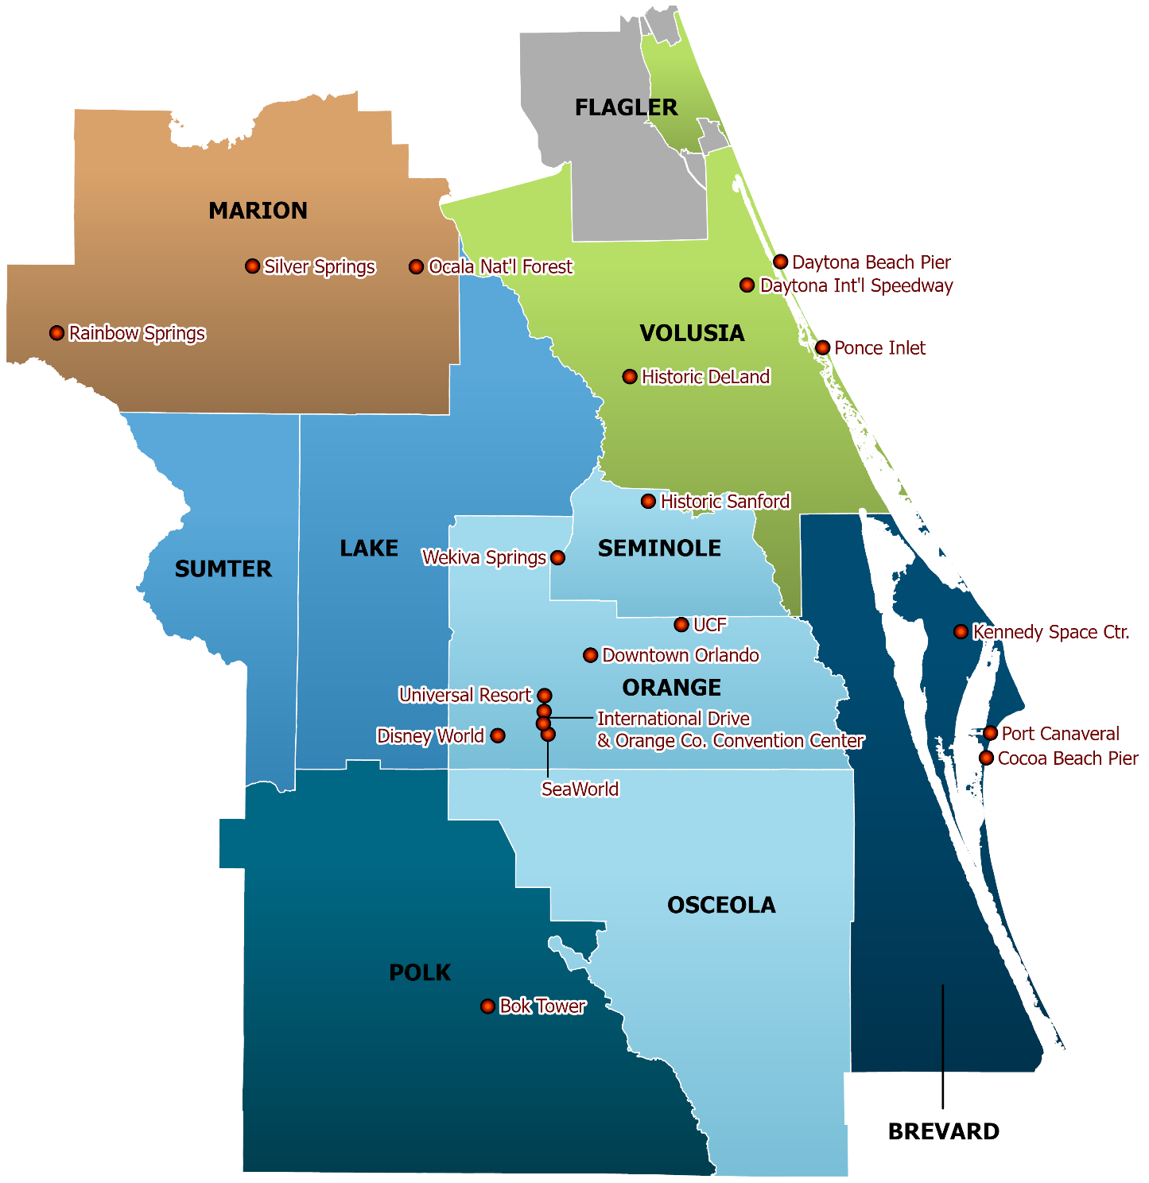
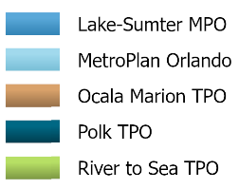
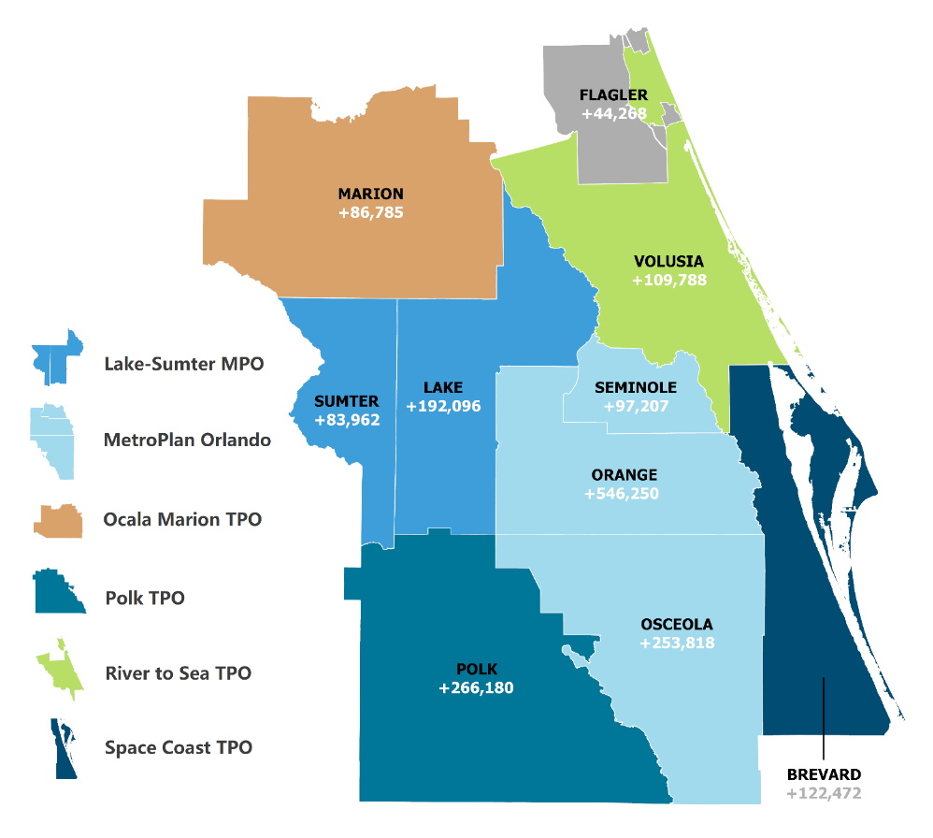
Regional Destinations
2.3 | Regional Demographics

The tables below provide detailed breakdowns of the composition of the Central Florida MPO Alliance region, its ten counties, and its six member TPO’s. Statistics in the analysis include population by age ranges (0-17, 18-64, and 65+), median household income, and household poverty rates for 2021 as approximated by the U.S. Census Bureau’s July 2021 estimates.⁶

The charts on the following page depict this information for each of the six TPO’s included in the Central Florida MPO Alliance region.

Demographics | Median H.H Income | Poverty Rate  (% Households) | Percent Aged  0-17 | Percent Aged  18-64 | Percent Aged  65+
Brevard County | $59,359 | 9.9% | 18.2% | 57.6% | 24.2%
Flagler County* | $57,536 | 9.4% | 16.4% | 52.5% | 31.1%
Lake County | $55,792 | 9.2% | 19.2% | 54.3% | 26.5%
Marion County | $46,587 | 15.3% | 18.8% | 52.5% | 28.7%
Orange County | $61,416 | 12.7% | 21.6% | 65.6% | 12.8%
Osceola County | $55,538 | 11.8% | 24.2% | 62.4% | 13.4%
Polk County | $51,535 | 14.4% | 22.1% | 58.1% | 19.8%
Seminole County | $70,297 | 8.0% | 20.8% | 62.8% | 16.4%
Sumter County | $59,618 | 12.3% | 7.0% | 34.8% | 58.2%
Volusia County | $52,407 | 11.6% | 17.6% | 57.4% | 25.0%
CFMPOA Region | $57,496 | 11.9% | 20.1% | 59.3% | 20.6%
* Portions of Flagler County are not included in the CFMPOA Alliance region. This table includes all of Flagler County
Source(s): U.S. Census Bureau, V2021 Estimates
Demographics | Median H.H Income | Poverty Rate  (% Households) | Percent Aged  0-17 | Percent Aged  18-64 | Percent Aged  65+
Lake-Sumter MPO | $56,768 | 10.0% | 16.1% | 49.3% | 34.6%
MetroPlan Orlando | $62,202 | 11.6% | 21.9% | 64.5% | 13.6%
Ocala Marion TPO | $46,587 | 15.3% | 18.8% | 52.5% | 28.7%
Polk TPO | $51,535 | 14.4% | 22.1% | 58.1% | 19.8%
River to Sea TPO* | $53,312 | 11.2% | 17.4% | 56.5% | 26.1%
Space Coast TPO | $59,359 | 9.9% | 18.2% | 57.6% | 24.2%
* Portions of Flagler County are not included in the CFMPOA Alliance region. This table includes all of Flagler County
Source(s): U.S. Census Bureau, V2021 Estimates

USDOT Transportation Disadvantaged Census Tracts
The U.S. Department of Transportation identifies Census Tracts as disadvantaged when the tract has high levels of risk associated with specified categories. These categories include low levels of transportation access, health disadvantages based on health outcomes, high levels of pollutants, economic disadvantages, resilience disadvantages, and areas with a shared history of discrimination.⁷ The map below depicts disadvantaged Census Tracts in black.

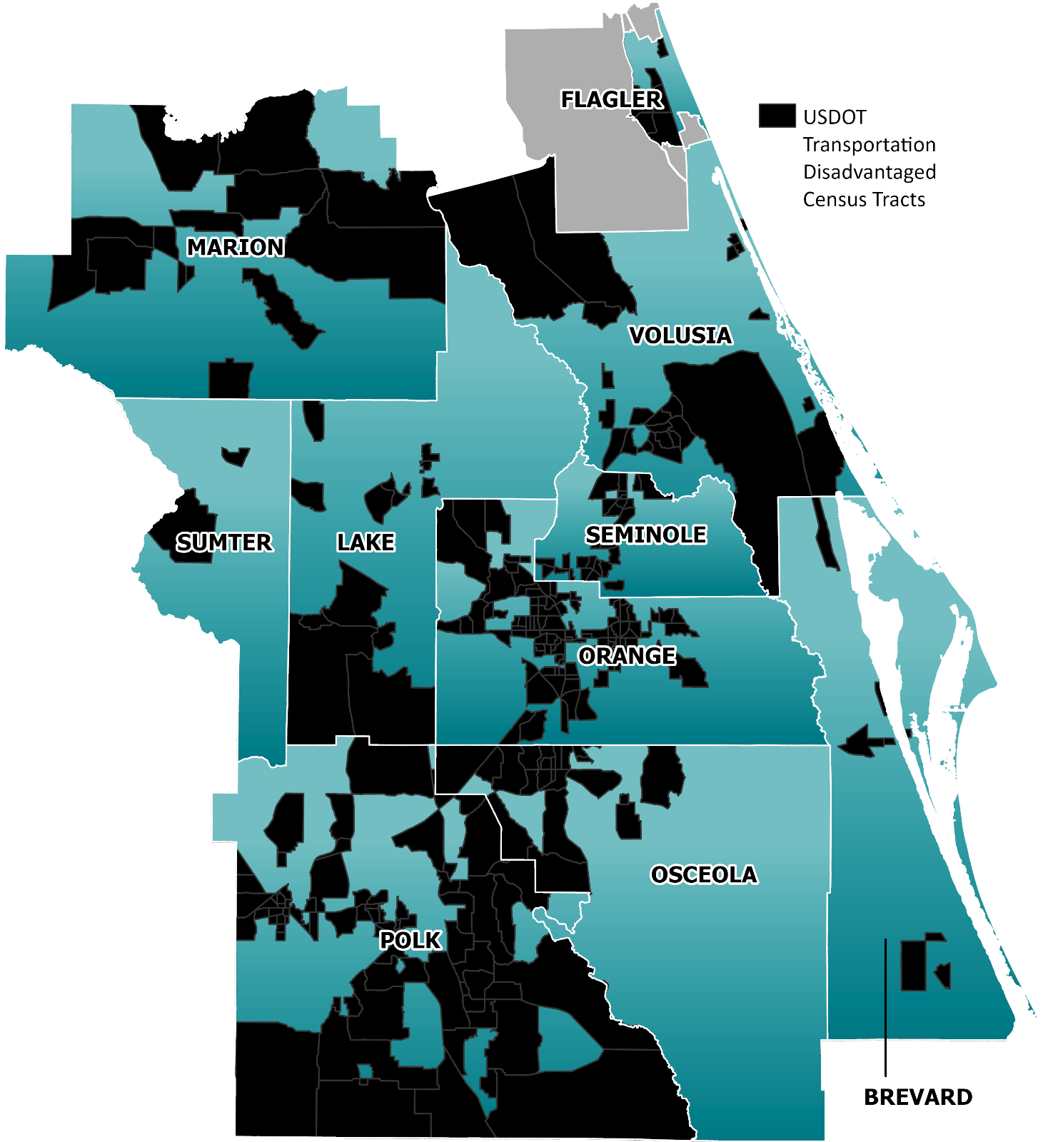
Transportation Disadvantaged
Census Tracts
2.4 | Land Use & Urbanization

This section of the report analyzes land uses across three categories: active land uses, agricultural lands, and conservation lands.

Active Land Uses
Existing Land Use – Not Including Agricultural and Recreational Lands

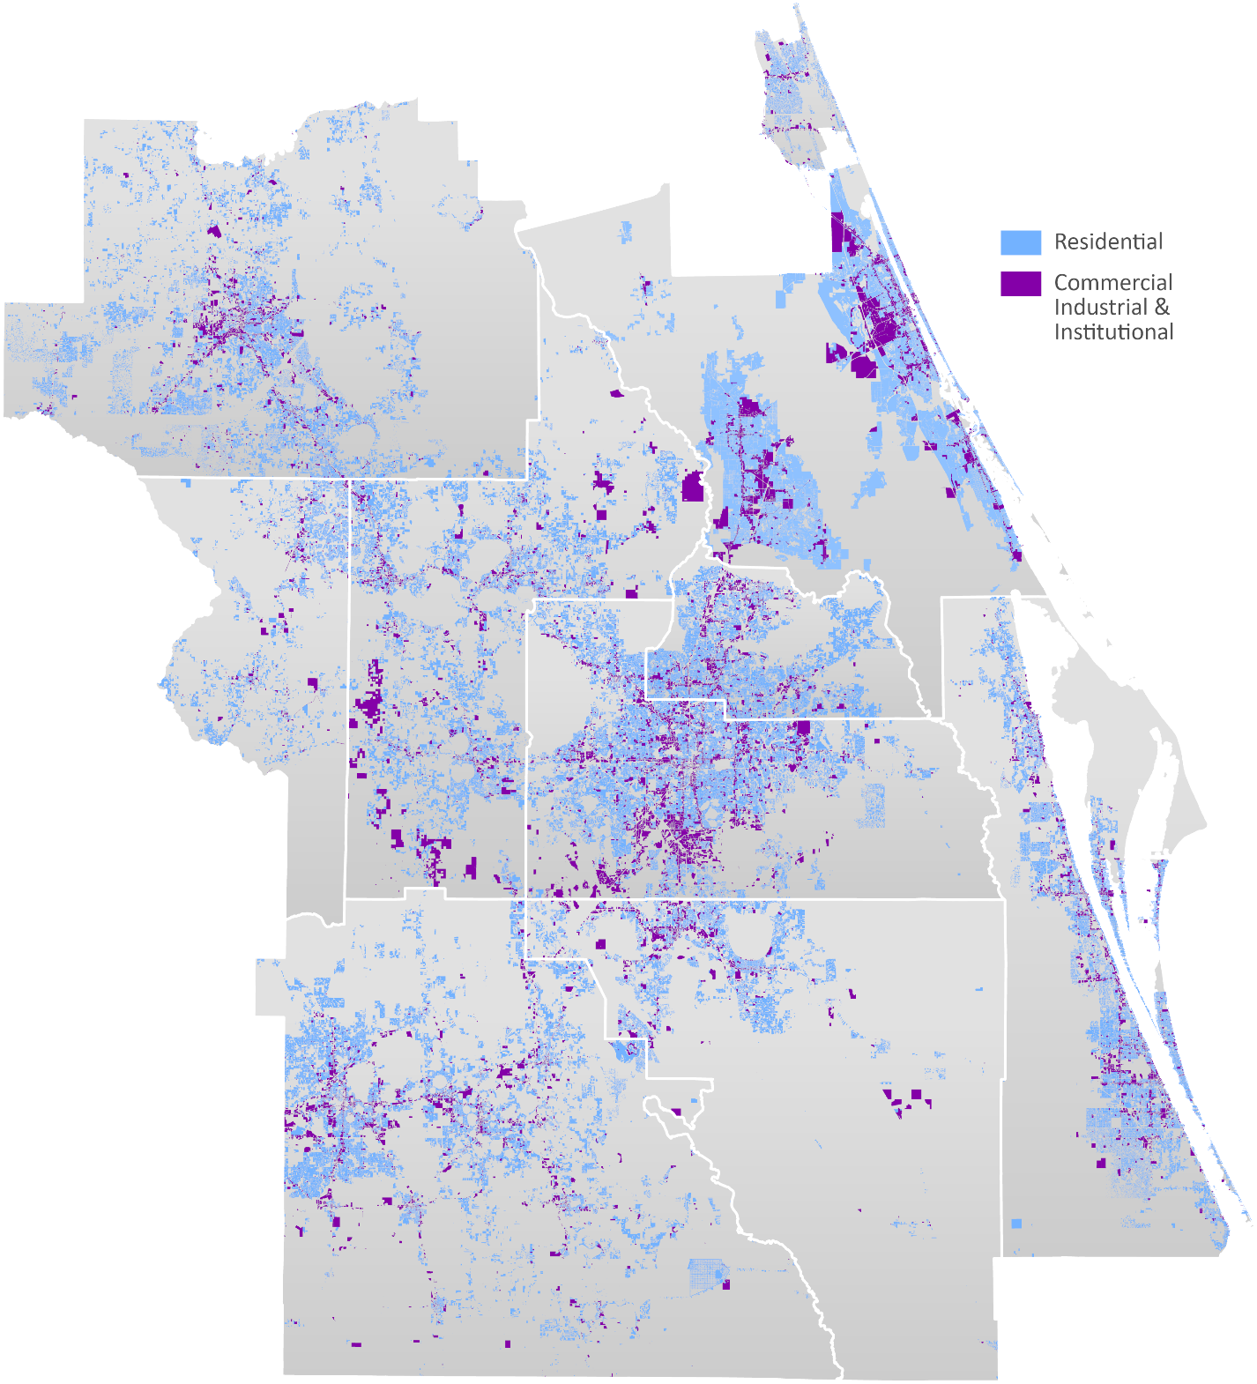
The map below depicts active land uses in the Central Florida MPO Alliance region. Lodging, office, industrial, and institutional land uses are classified one land use type.⁸
Note: Volusia County land use file obtained from ECFRPC includes incorrect values in the southern portion of the County.

The Volusia County future land use file is depicted as a result of these inaccuracies.
Active Land Uses
Agricultural Lands
Existing Land Use

The following map depicts agricultural areas in green.⁹ Regionwide, there are more than 2.2 million acres of agricultural land.

Lake-Sumter MPO: 374,747 Acres Polk TPO: 577,819 Acres
MetroPlan Orlando: 715,995 Acres River to Sea TPO: 148,491 Acres +
Ocala Marion TPO: 415,225 Acres Space Coast TPO: 20,290 Acres
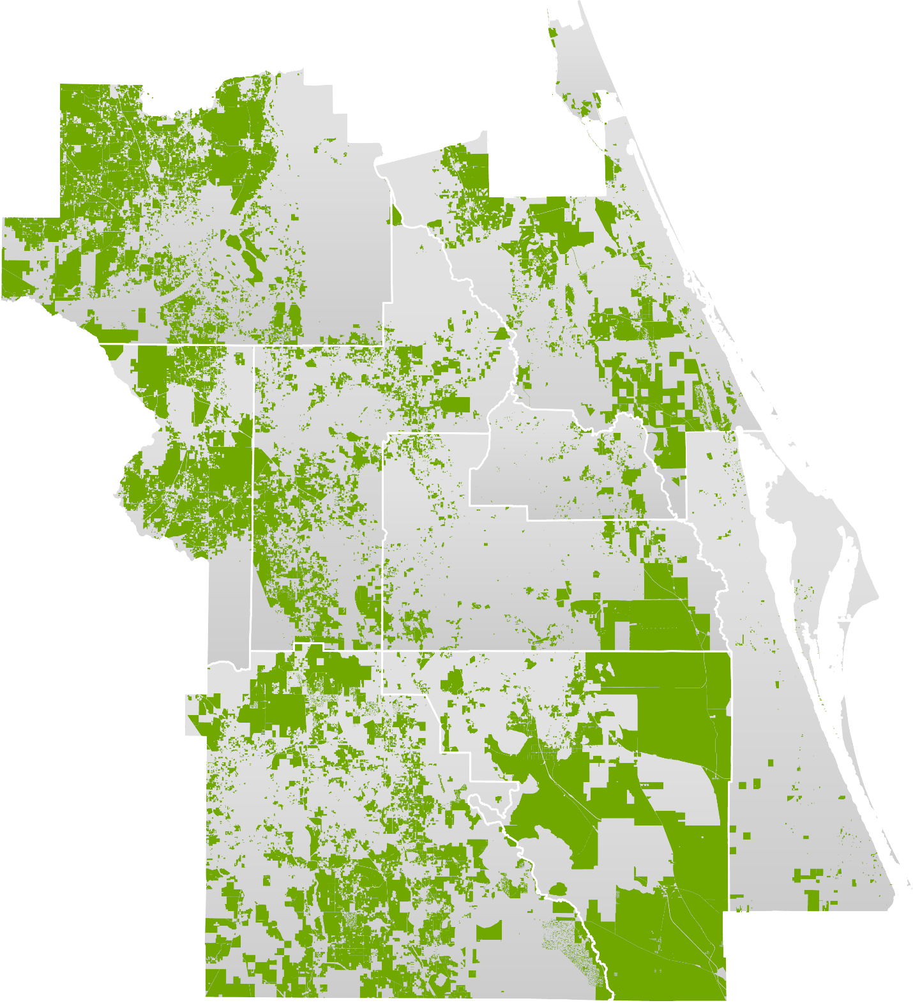
Agricultural Land
Note: Volusia County land use file obtained from ECFRPC includes incorrect values in the southern portion of the County.

Agricultural future land uses in Volusia County are shown in this map but are not shown in the acreage number.
Conservation Lands
Future Land Use

The following map depicts conservation areas in green.^{10, 11} Regionwide, there are more than 1.7 million acres of conservation land.

Lake-Sumter MPO: 357,234 Acres Polk TPO: 299,468 Acres
MetroPlan Orlando: 207,194 Acres River to Sea TPO: 307,594 Acres
Ocala Marion TPO: 398,599 Acres Space Coast TPO: 167,651 Acres
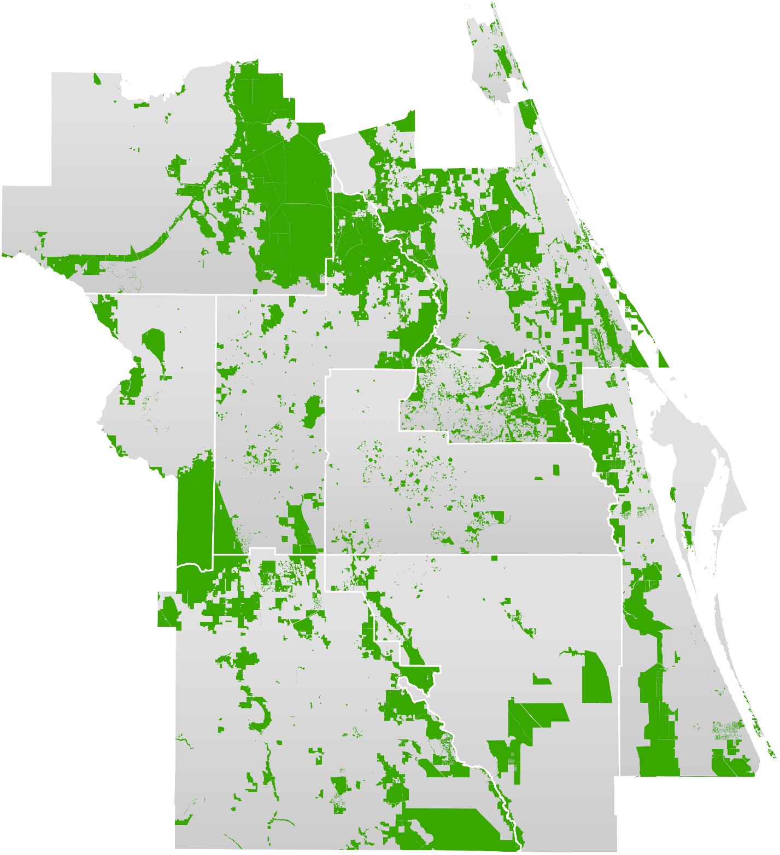
Agricultural Land
3 | Regional Assets

Section Outline
3.1: Land Assets
3.2: Air Assets
3.3: Sea Assets
3.4: Space Assets

3.1 | Land Assets

This section of the report provides detailed analysis of trends relating to land transportation assets that serve the Central Florida MPO Alliance region.

State Highway System
There are numerous categories of roadway analyzed in this report, including the National Highway System (NHS), the State Highway System (SHS), the Strategic Intermodal System (SIS), and the roadways included in the Florida Department of Transportation Road Classification Index (RCI). The RCI includes all roadways in the three aforementioned roadway classifications and is the most comprehensive network from an analytical perspective.

The table below summarizes the total number of State Highway System (SHS) miles present by TPO in the Central Florida MPO Alliance region.¹² Additional state and local system analytics are included in future sections of this report, in addition to Appendix 2.

State Highway System Lane Miles | 2017 | 2018 | 2019 | 2020 | 2021 | 2017-21
 |  |  |  |  |  | % Change
Lake-Sumter MPO | 1,184 | 1,197 | 1,249 | 1,254 | 1,259 | 6.3%
MetroPlan Orlando | 3,236 | 3,250 | 3,334 | 3,343 | 3,370 | 4.1%
Ocala Marion TPO | 935 | 936 | 944 | 942 | 942 | 0.7%
Polk TPO | 1,669 | 1,669 | 1,671 | 1,682 | 1,682 | 0.8%
River to Sea TPO* | 1,738 | 1,738 | 1,744 | 1,744 | 1,768 | 1.7%
Space Coast TPO | 1,398 | 1,400 | 1,401 | 1,399 | 1,403 | 0.4%
CFMPOA Region | 10,160 | 10,190 | 10,343 | 10,364 | 10,424 | 2.6%
Source(s): Florida Dept. of Transportation, Reports of Highway Mileage

The maps on the following three pages of the report depict FDOT RCI roadways classified by the following metrics, with table summaries:

- Functional Classification¹³
- Annual Average Daily Traffic¹⁴
- Pavement Conditions¹⁵
FDOT Roadways – Functional Classification (FDOT RCI Roadways)
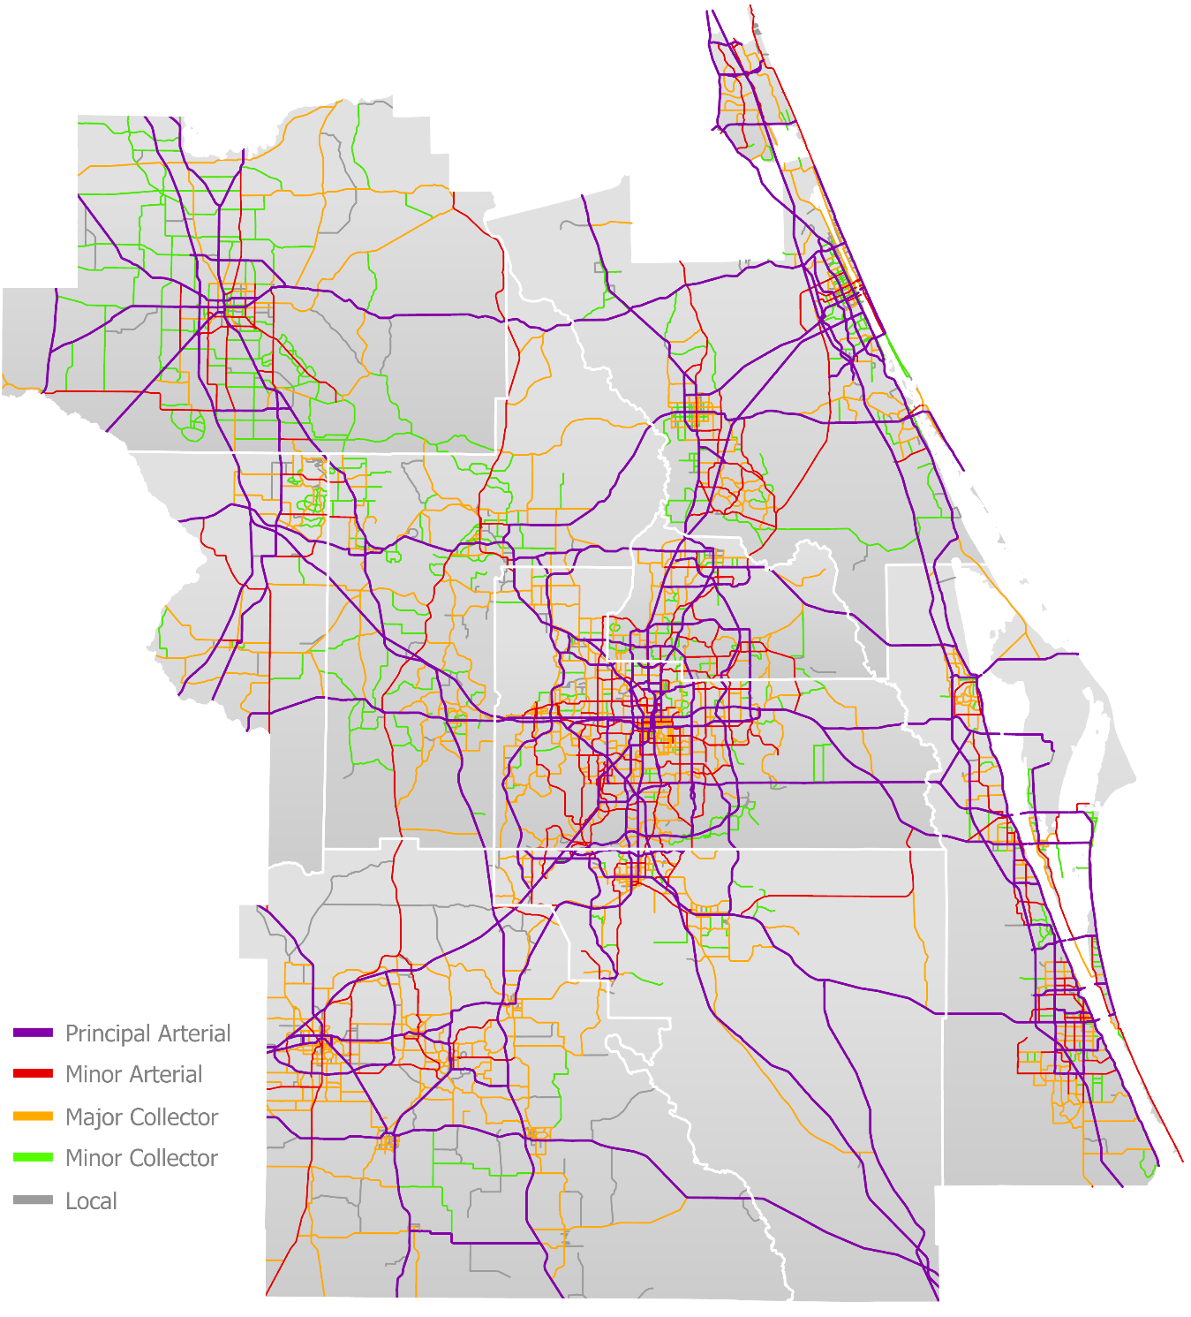
Functional Classification
Functional Classification | Principal Arterial | Minor Arterial | Major Collector | Minor Collector
 | Miles | Miles | Miles | Miles
Lake-Sumter MPO | 273 | 136 | 404 | 250
MetroPlan Orlando | 749 | 448 | 788 | 213
Ocala Marion TPO | 223 | 130 | 192 | 409
Polk TPO | 307 | 141 | 539 | 39
River to Sea TPO | 403 | 186 | 251 | 218
Space Coast TPO | 336 | 158 | 233 | 91
CFMPOA Region | 2,291 | 1,199 | 2,407 | 1,220
*603 miles of “Local” roadways not included
FDOT Roadways – Annual Average Daily Traffic (AADT) (FDOT RCI Roadways)
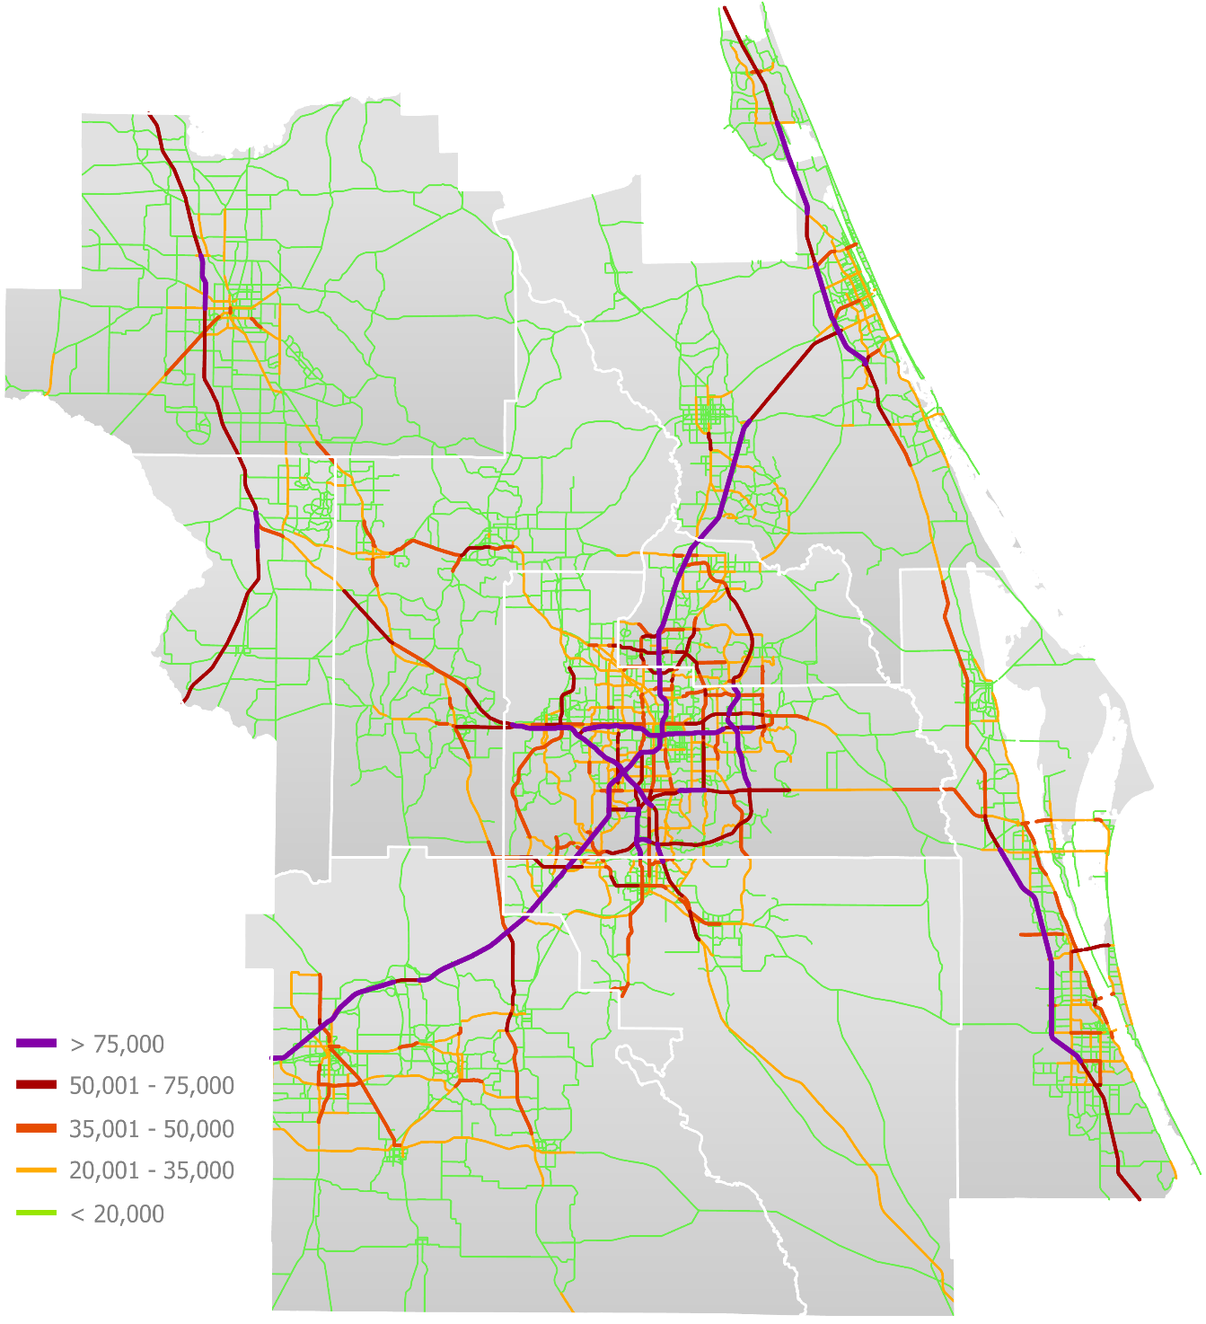
Annual Average
Daily Traffic
Daily Traffic | < 20,000 | 20,001 - 35,000 | 35,001 - 50,000 | 50,001 - 75,000 | > 75,000
 | Miles | Miles | Miles | Miles | Miles
Lake-Sumter MPO | 918 | 84 | 41 | 47 | 4
MetroPlan Orlando | 1,549 | 482 | 176 | 132 | 104
Ocala Marion TPO | 871 | 72 | 12 | 33 | 5
Polk TPO | 834 | 145 | 57 | 13 | 29
River to Sea TPO | 913 | 144 | 16 | 42 | 36
Space Coast TPO | 619 | 126 | 68 | 25 | 25
CFMPOA Region | 5,704 | 1,053 | 370 | 292 | 203
FDOT Roadways – Pavement Conditions (FDOT RCI Roadways)
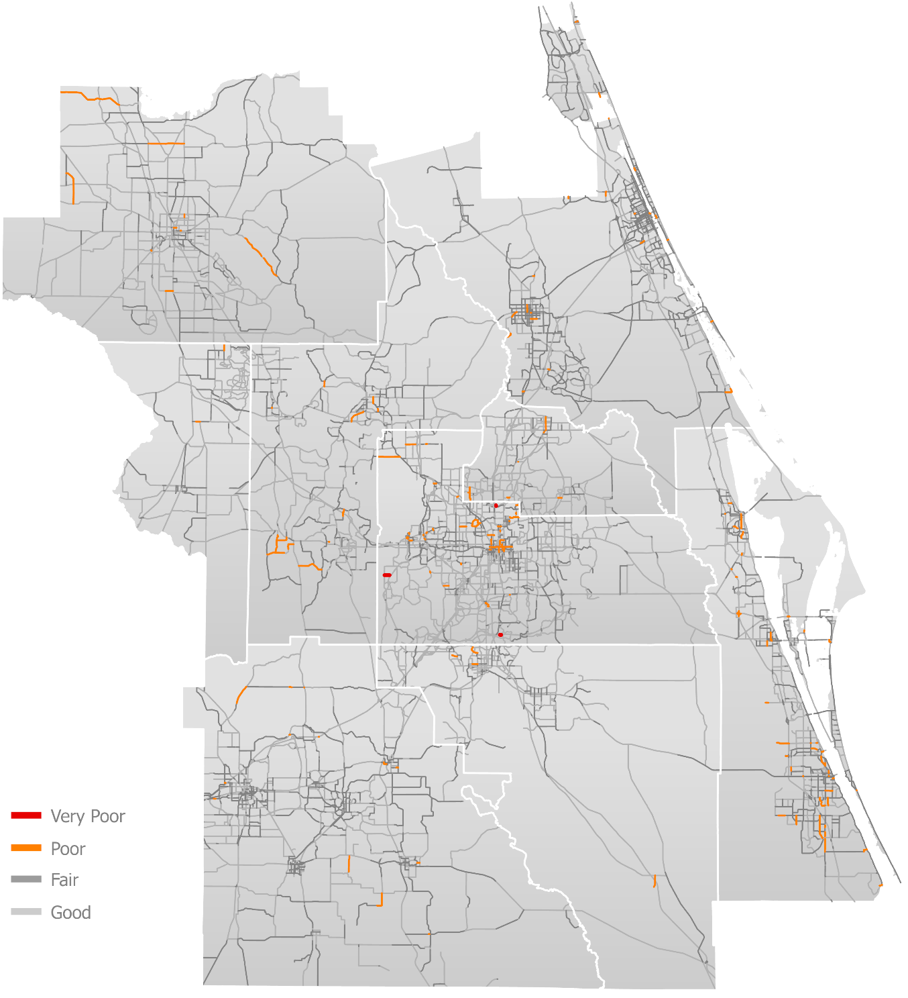
Pavement
Conditions
Pavement Condition | Very Good | Good | Fair | Poor | Very Poor
 | Miles | Miles | Miles | Miles | Miles
Lake-Sumter MPO | 464 | 687 | 335 | 22 | 0
MetroPlan Orlando | 1,160 | 2,091 | 585 | 38 | 1
Ocala Marion TPO | 350 | 659 | 261 | 28 | 0
Polk TPO | 66 | 1,062 | 608 | 10 | 0
River to Sea TPO | 388 | 557 | 721 | 12 | 0
Space Coast TPO | 328 | 521 | 425 | 35 | 0
CFMPOA Region | 2,756 | 5,577 | 2,935 | 145 | 1
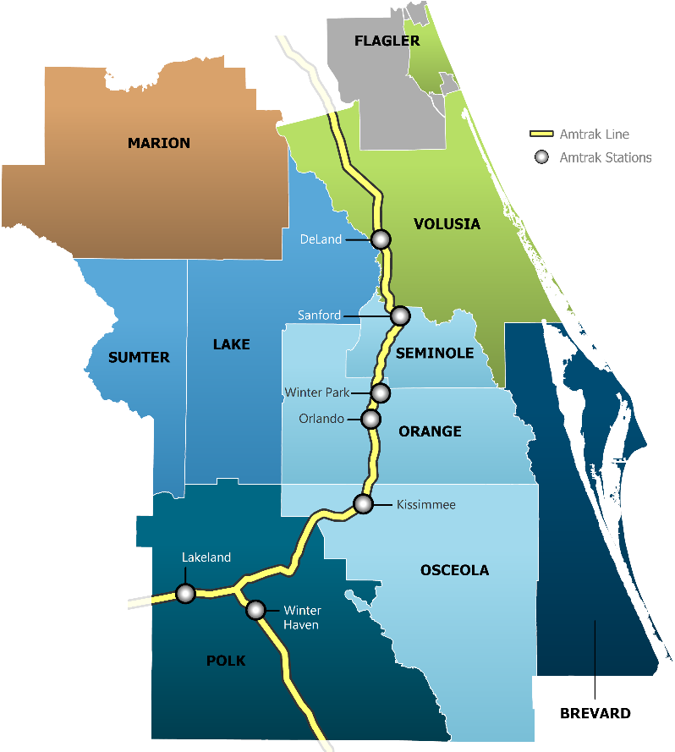
Amtrak
Amtrak serves the Central Florida MPO Alliance with seven stations that connect to cities throughout the state of Florida and the United States. The analysis in this section of the report summarizes Amtrak ridership in the Central Florida region from 2012 to 2021.¹⁶



Amtrak Ridership | 2017 | 2018 | 2019 | 2020 | 2021
Station
DeLand | 20,827 | 20,677 | 20,453 | 12,338 | 10,433
Kissimmee | 35,737 | 35,028 | 35,726 | 20,757 | 21,158
Lakeland | 19,479 | 18,924 | 19,186 | 10,733 | 2,651
Orlando | 133,248 | 127,326 | 127,186 | 72,267 | 73,327
Sanford | 228,943 | 224,812 | 236,035 | 163,468 | 197,708
Winter Haven | 20,598 | 20,503 | 19,757 | 13,321 | 15,227
Winter Park | 27,253 | 25,844 | 27,047 | 14,828 | 12,993
CFMPOA Region | 486,085 | 473,114 | 485,390 | 307,712 | 333,497


SunRail
SunRail serves Volusia, Seminole, Orange and Osceola Counties and began operations in 2014. Following partial service during fiscal year 2013-14, operations ramped up and annual passenger numbers stayed fairly consistent from fiscal year 2014-15 to fiscal year 2018-19. In fiscal year 2018-19, four new stations opened and ridership increased 77% year over year before plummeting in fiscal year 2020-21 as a result of the COVID-19 pandemic.¹⁷

SunRail Ridership | 2016-17 | 2017-18 | 2018-19 | 2019-20 | 2020-21
Station
Poinciana | Not Open | Not Open | 82,854 | 74,954 | 10,621
Kissimmee | Not Open | Not Open | 98,479 | 88,897 | 15,039
Tupperware | Not Open | Not Open | 43,312 | 38,822 | 5,456
Meadow Woods | Not Open | Not Open | 101,920 | 104,766 | 13,644
Sand Lake Road | 107,691 | 101,178 | 75,379 | 57,659 | 9,188
Orlando Health | 33,100 | 32,166 | 76,221 | 70,558 | 11,681
Church Street | 100,215 | 95,524 | 168,870 | 139,179 | 10,594
LYNX | 98,981 | 93,516 | 153,046 | 137,829 | 25,519
AdventHealth | 49,664 | 49,244 | 87,164 | 74,175 | 13,324
Winter Park | 95,429 | 81,590 | 128,932 | 97,760 | 12,619
Maitland | 41,505 | 38,338 | 51,156 | 44,715 | 4,856
Altamonte Springs | 61,388 | 56,033 | 69,467 | 56,191 | 9,886
Longwood | 60,432 | 55,280 | 64,553 | 50,801 | 7,849
Lake Mary | 85,440 | 75,131 | 85,969 | 68,219 | 8,997
Sanford | 64,374 | 60,988 | 74,615 | 58,773 | 10,034
DeBary | 102,937 | 92,472 | 107,717 | 80,265 | 13,787
Total SunRail Ridership | 901,156 | 831,460 | 1,469,654 | 1,243,563 | 183,094

Bus Transit
Six bus transit agencies serve the Central Florida MPO Alliance region at different capacities. This portion of the report summarizes bus activity (annual revenue miles and revenue hours), vehicles at peak service, and transit usage (annual passenger miles and trips per capita).¹⁸



321 Transit | 2016 | 2017 | 2018 | 2019 | 2020
Usage Metrics
Revenue Miles | 2,748,404 | 2,569,149 | 2,505,383 | 2,503,841 | 2,327,251
Revenue Hours | 115,490 | 116,583 | 115,583 | 115,954 | 111,476
Peak Vehicles | 74 | 75 | 70 | 66 | 74
Passenger Miles | 18,850,305 | 16,730,819 | 15,900,372 | 15,559,236 | 11,395,341
Trips Per Capita | 4.18 | 3.86 | 3.81 | 3.69 | 2.76
Source(s): Florida Dept. of Transportation
Citrus Connection Usage | 2016 | 2017 | 2018 | 2019 | 2020
Usage Metrics
Revenue Miles | 1,372,618 | 1,378,277 | 1,457,881 | 1,465,800 | 1,654,747
Revenue Hours | 89,104 | 90,759 | 92,634 | 89,311 | 99,561
Peak Vehicles | 30 | 32 | 32 | 30 | 39
Passenger Miles | 8,076,814 | 7,088,796 | 6,480,784 | 6,722,792 | 4,514,472
Trips Per Capita | 4.18 | 4.01 | 1.67 | 1.68 | 1.09
Source(s): Florida Dept. of Transportation
Lake Xpress Usage | 2016 | 2017 | 2018 | 2019 | 2020
Usage Metrics
Revenue Miles | 538,386 | 586,083 | 571,150 | 567,788 | 569,841
Revenue Hours | 30,345 | 33,843 | 33,859 | 34,221 | 34,401
Peak Vehicles | 10 | 10 | 10 | 10 | 10
Passenger Miles | 2,094,737 | 2,162,788 | 2,132,469 | 2,137,828 | 1,672,249
Trips Per Capita | 3.24 | 3.41 | 3.49 | 3.63 | 2.69
Source(s): Florida Dept. of Transportation
LYNX Usage | 2016 | 2017 | 2018 | 2019 | 2020
Usage Metrics
Revenue Miles | 18,553,326 | 19,133,549 | 18,272,240 | 18,478,080 | 16,919,718
Revenue Hours | 1,223,991 | 1,257,909 | 1,251,917 | 1,262,449 | 1,172,094
Peak Vehicles | 435 | 455 | 457 | 471 | 460
Passenger Miles | 143,072,210 | 147,579,931 | 146,678,748 | 155,663,432 | 94,773,252
Trips Per Capita | 12.57 | 11.92 | 11.54 | 11.45 | 8.06
Source(s): Florida Dept. of Transportation
SunTran Usage | 2016 | 2017 | 2018 | 2019 | 2020
Usage Metrics
Revenue Miles | 494,223 | 484,444 | 484,964 | 480,893 | 420,323
Revenue Hours | 31,548 | 31,007 | 30,839 | 32,036 | 29,016
Peak Vehicles | 6 | 6 | 6 | 7 | 7
Passenger Miles | 2,242,744 | 2,146,425 | 2,181,109 | 1,979,804 | N/A
Trips Per Capita | 6.43 | 6.34 | 6.44 | 5.84 | 3.97
Source(s): Florida Dept. of Transportation
Votran Usage | 2016 | 2017 | 2018 | 2019 | 2020
Usage Metrics
Revenue Miles | 2,686,975 | 2,877,059 | 3,147,083 | 3,412,477 | 3,326,989
Revenue Hours | 172,630 | 180,728 | 197,698 | 208,295 | 210,226
Peak Vehicles | 56 | 58 | 69 | 76 | 77
Passenger Miles | 13,180,744 | 13,833,524 | 14,044,942 | 14,382,669 | 10,975,197
Trips Per Capita | 6.57 | 6.46 | 6.50 | 6.42 | 4.99
Source(s): Florida Dept. of Transportation

Freight Movement on Highways
Numerous high-capacity roadways run through the Central Florida MPO Alliance region with semi-trucks carrying goods across the state and nation. Major corridors include Interstate-95, Interstate-4, Interstate 75, Florida’s Turnpike, State Road 417, and numerous other state and county roads.

The map below depicts the highest-volume trucking corridors in the Central Florida MPO Alliance region, color coded by annual average daily truck traffic.¹⁹
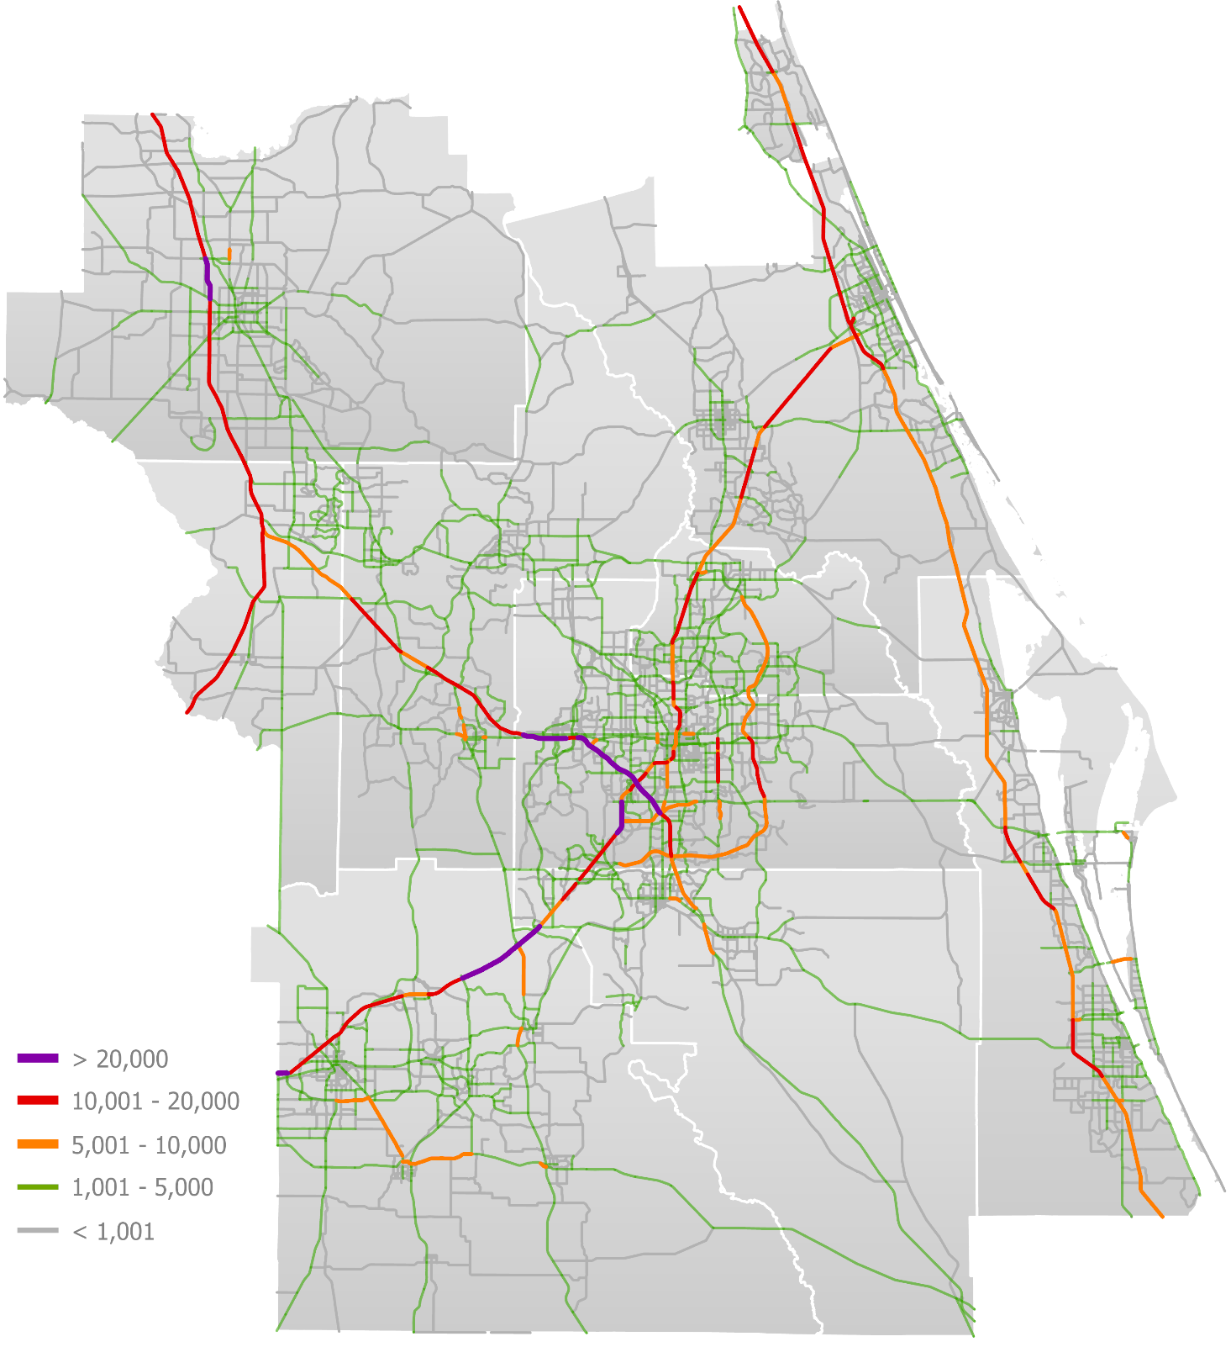
Truck AADT
(Annual Average Daily Traffic)
National Freight Corridors
The Federal Highway Administration’s national freight network, depicted in the map below, closely aligns with the daily truck volumes depicted in the map on the previous page.

Critical corridors within the Central Florida MPO Alliance region that are a part of this system include Interstate-95, Interstate-75, Interstate-4, Florida’s Turnpike, State Road 528, U.S. Highway 27, U.S. Highway 301, and other corridors within the core of the Orlando Metro Area. The map below depicts the three major classifications of freight networks as defined by FHWA.²⁰
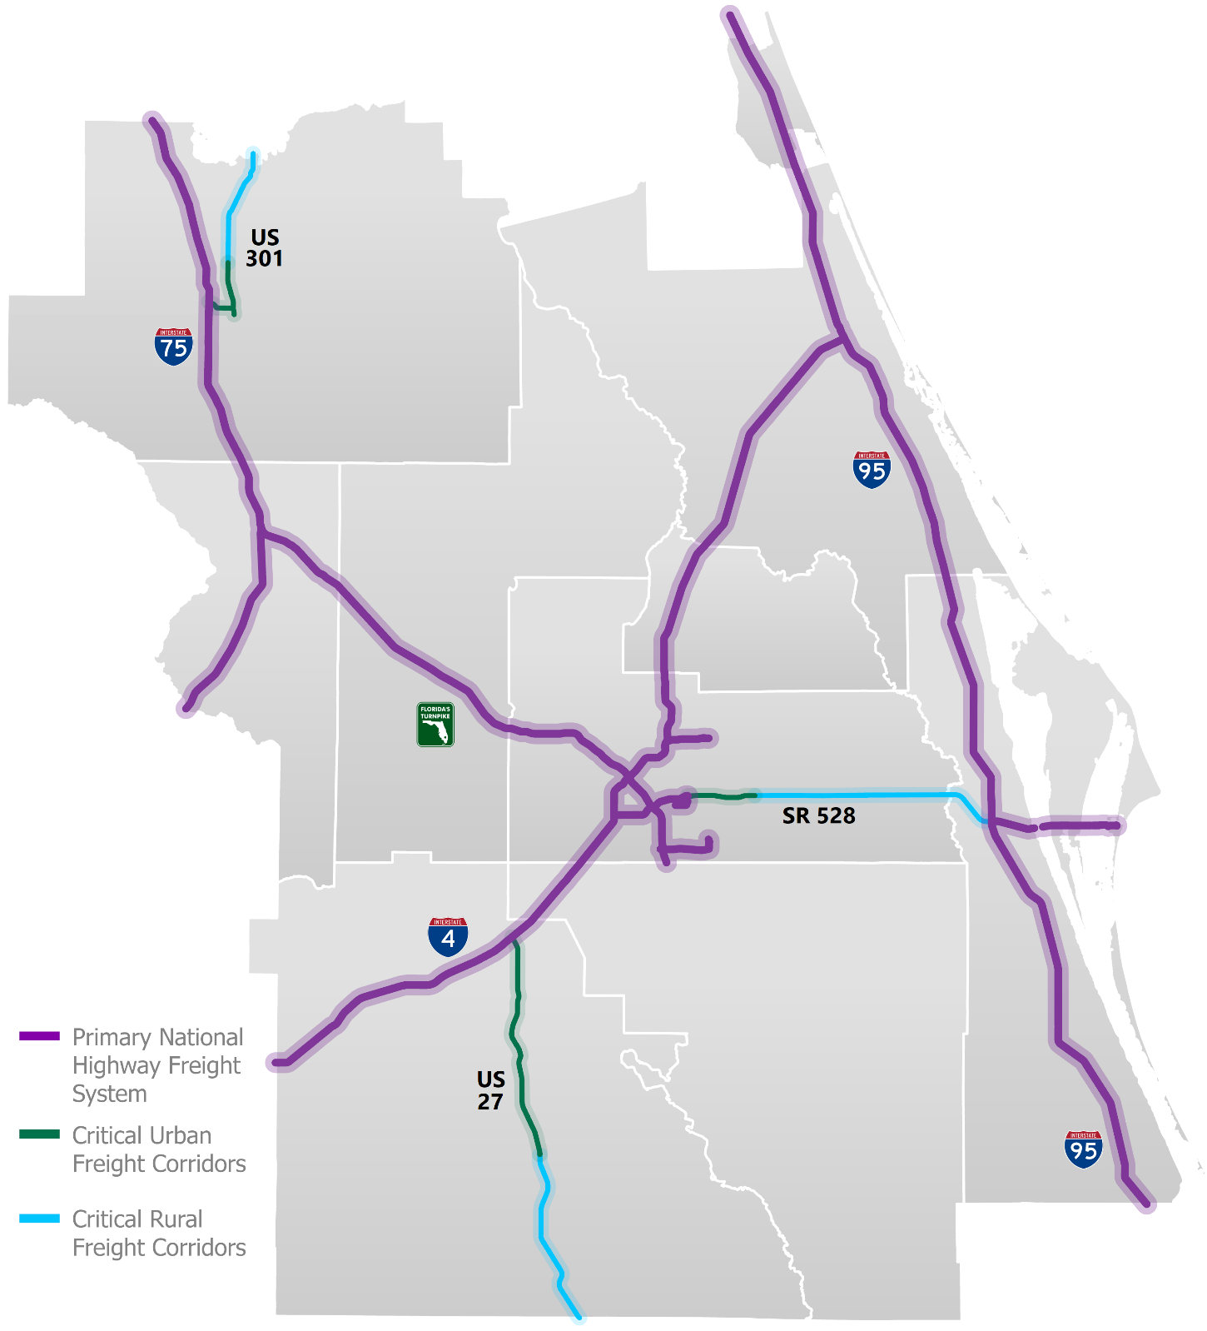
FHWA
Freight System
Railroads
The map below depicts railroads in the Central Florida MPO Alliance region.²¹ The primary railroad in the region is the Florida East Coast Railway, which travels from Jacksonville to Miami and is shown on the far east side of the map below. This railway is not directly connected to the region’s other railways, as many segments have been discontinued over the last 100 years.

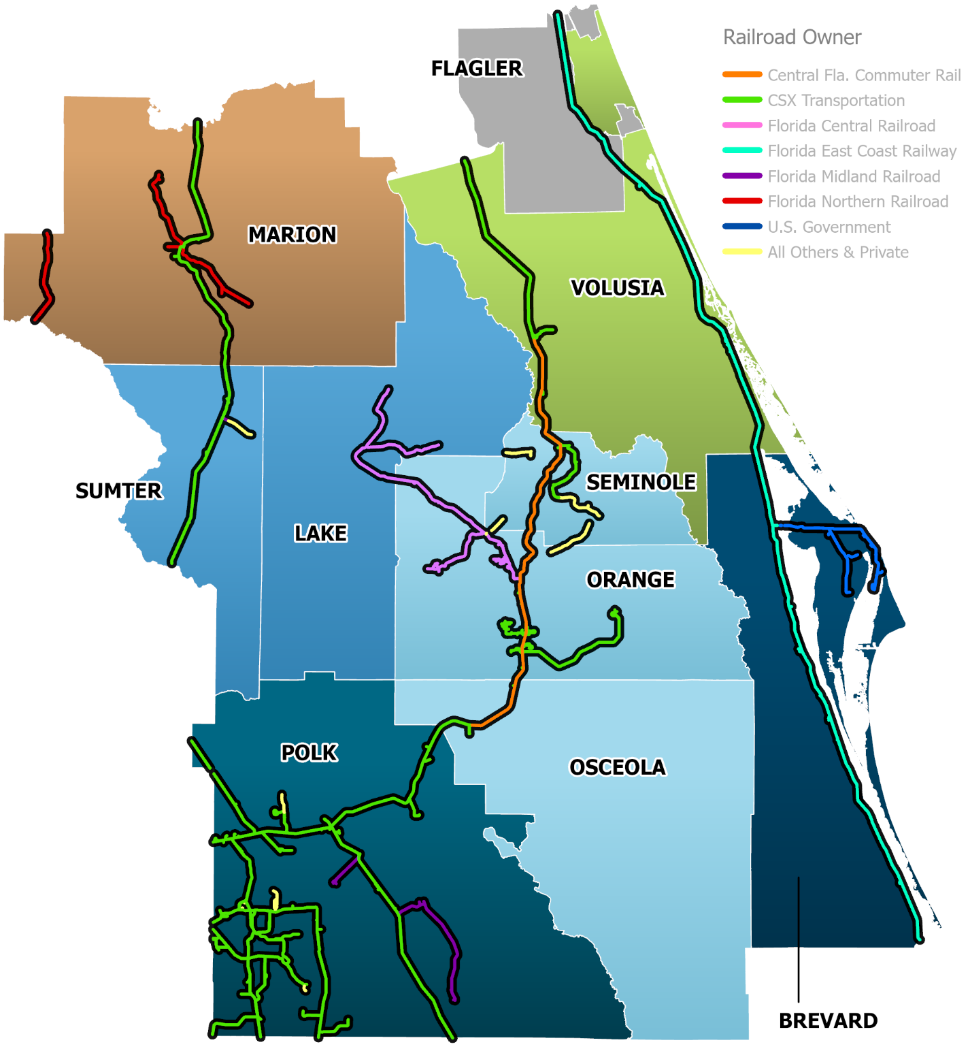
CSX Transportation is the owner and operator of the vast majority of the other railroads in the region, as seen traversing in the map below through Lake, Marion, Orange, Osceola, Polk, Seminole, Sumter and western Volusia Counties. Smaller segments of railroad are owned and operated by other third parties.
Railroads
Bridges
The table below provides summary statistics on land-and-sea-bridges in the Central Florida MPO Alliance region.²² The map depicts these bridges in yellow.

Bridges | Number of Bridges | Bridge Miles | Avg. Bridge Miles
Lake-Sumter MPO | 180 | 6.83 | 0.04
MetroPlan Orlando | 997 | 54.05 | 0.05
Ocala Marion TPO | 68 | 3.50 | 0.05
Polk TPO | 257 | 8.67 | 0.03
River to Sea TPO* | 203 | 15.05 | 0.07
Space Coast TPO | 185 | 14.32 | 0.08
CFMPOA Region | 1,890 | 102.42 | 0.05
Source(s): Florida Dept. of Transportation
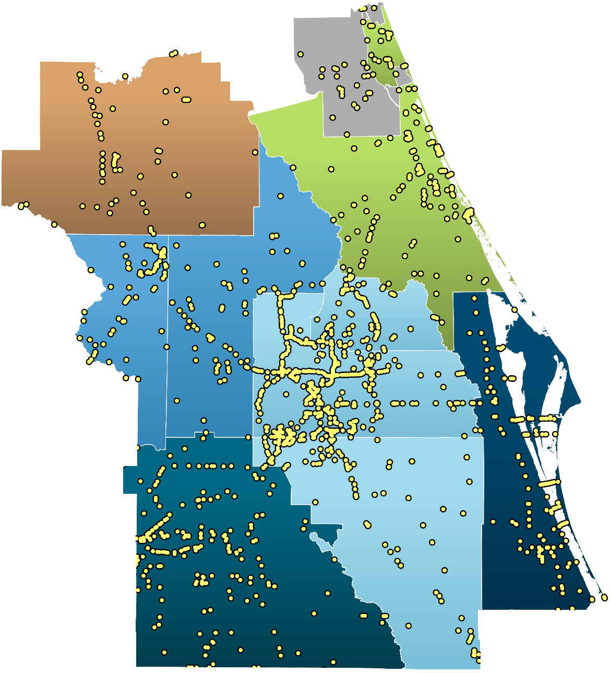
Land and Sea Bridges

Brightline
Beginning in mid-2023, Brightline will provide high speed rail service between south Florida and Orlando International Airport. Following this initial phase, service is preliminarily planned to connect to the Tampa Bay region to the west. The expansion from Orlando International Airport to Tampa Bay will include a station at Walt Disney World, providing the first ever multi-modal connection between the two visitation hot spots.²³

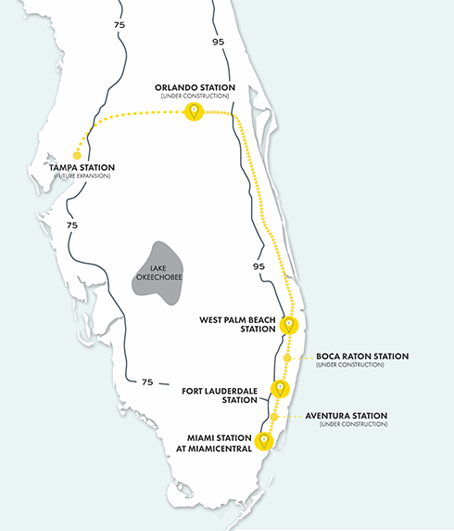
Image Source: Brightline
3.2 | Air Assets

The Central Florida MPO Alliance region has seven international airports, headlined by Orlando International Airport, one of the busiest airports in the U.S. In addition, the region has 15 municipal/regional airports and two air force bases utilized by the U.S. Military. The map on this page depicts these air assets, by type, and the tables on the following pages provide summaries on passenger volumes for the region’s four largest international airports.²⁴

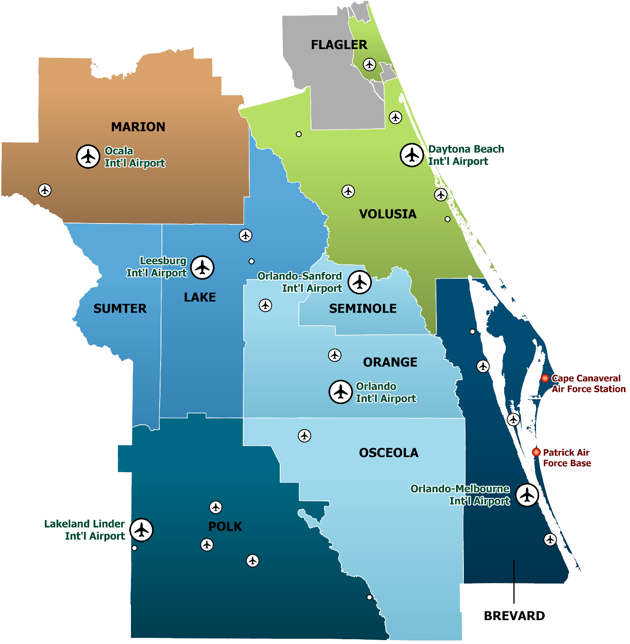
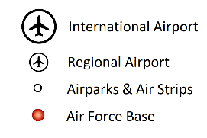
Airports, Airparks, Air
Strips & Air Force Bases

Orlando | 2017 | 2018 | 2019 | 2020 | 2021
Total Passengers | 43,591,361 | 47,696,627 | 50,617,412 | 21,617,803 | 40,351,068
Tons of Cargo | 248,267 | 260,305 | 285,964 | 247,063 | 245,147
Departure Reliability % | 78% | 77% | 77% | 85% | N/A
Source(s): Federal Aviation Administration; U.S Bureau of Transportation Statistics; Orlando International Airport (2022)

Orlando-Sanford | 2017 | 2018 | 2019 | 2020 | 2021
Total Passengers | 2,922,446 | 3,094,487 | 3,291,112 | 1,545,041 | 2,396,108
Tons of Cargo | 415 | 225 | 685 | 30 | 0
Departure Reliability % | N/A | 79% | 83% | 72% | N/A
Source(s): Federal Aviation Administration; U.S Bureau of Transportation Statistics; Orlando-Sanford International Airport (2022)

Orlando-Melbourne | 2017 | 2018 | 2019 | 2020 | 2021
Total Passengers | 467,096 | 489,240 | 498,184 | 232,832 | 372,287
Tons of Cargo | 75 | 93 | 33 | 0 | 0
Departure Reliability % | 86% | 87% | 86% | 87% | N/A
Source(s): Federal Aviation Administration; U.S Bureau of Transportation Statistics; Orlando-Melbourne International Airport (2022)

Daytona Beach | 2017 | 2018 | 2019 | 2020 | 2021
Total Passengers | 720,825 | 763,538 | 713,287 | 332,835 | 576,637
Tons of Cargo | 130 | 97 | 61 | 11 | 1
Departure Reliability % | 84% | 82% | 85% | 87% | N/A
Source(s): Federal Aviation Administration; U.S Bureau of Transportation Statistics; Daytona Beach International Airport (2022)
3.3 | Sea Assets

Port Canaveral is a major port that moves cargo and cruise passengers to and from the central Florida coast. The port is the second busiest cruise terminal in the world, serving millions of cruise passengers per year.²⁵ With the onset of the COVID-19 pandemic, the global cruise industry came to a halt, decreasing the number of cruise passengers embarking from Port Canaveral by more than 90% from 2020 to 2021.The table and chart below summarize the number of cruise passengers and tons of cargo that have used Port Canaveral, by year.²⁶

Port Canaveral | 2017 | 2018 | 2019 | 2020 | 2021
Total Passengers | 4,526,626 | 4,841,003 | 4,885,314 | 2,387,526 | 233,216
Tons of Cargo | 5,990,735 | 6,417,125 | 6,329,095 | 4,778,369 | 5,202,534
Source(s): Florida Seaport Transportation and Economic Development (FSTED) Council; Port Canaveral

3.4 | Space Assets

Kennedy Space Center is among the most unique assets of the Central Florida MPO Alliance region. Since the 1960’s, NASA has used the site to launch spacecraft, satellites, cargo and astronauts into space and to the International Space Station. The site has seen a recent resurgence of launch activity, with 130 launches occurring since 2017. In 2021, 8 astronauts were launched into space, ending a multiyear period of no astronauts being launched into space from the United States following the cancellation of the space shuttle program. The table below summarizes the number of astronauts launched into space and the total number of completed launches, by year.²⁷

Space Launches | 2017 | 2018 | 2019 | 2020 | 2021
Humans Launched | 0 | 0 | 0 | 0 | 8
Completed Launches | 19 | 20 | 18 | 31 | 42
Source(s): Space Florida
4 | Mega Trends

Section Outline
4.1: Safety Concerns
4.2: Air Quality
4.3: Transportation System Usage, Reliability & Congestion
4.4: E-Commerce & Remote Work
4.5: Electric Vehicles & Fuel Consumption
4.6: Autonomous Vehicles

+2.7%
Total Annual Vehicle Miles Traveled (VMT)
(2017 – 2021)
-5.1%
Annual Automobile-Involved Crashes – Fatal & Non-Fatal
(2017 – 2021)
-7.9%
Average Ozone Levels at Regional Monitoring Stations
(2017 – 2021)
+1.3%
Annual Bicyclist-and-Pedestrian-Involved Crashes
(2017 – 2021)

+10.3%
Percent of Retail Purchases Made Online
(2013 – 2022)
-3.1%
Annual Gasoline Consumption in Gallons
(2017 – 2021)

4.1 | Safety Concerns

This section of the report provides detailed tables, charts and maps summarizing automobile-involved crashes in the Central Florida MPO Alliance region from 2012 through 2021. The analyses are broken down by crash type. Crash types include 1) automobile-involved crashes, 2) fatal automobile-involved crashes, 3) bicyclist-and-pedestrian-involved crashes, and 4) fatal bicyclist-and-pedestrian-involved crashes. Crash summaries are further broken down by total number of crashes by County and TPO.
Automobile-Involved Crashes
The tables and chart below summarize automobile-involved crash statistics in the Central Florida MPO Alliance region. The region saw a moderate increase from 2012 to 2019 before a drop in 2020, likely as a result of lower traffic volumes due to COVID-19.²⁸

Automobile-Involved Crashes | 2017 | 2018 | 2019 | 2020 | 2021 | Total
 |  |  |  |  |  | 2017-2021
Brevard County | 15,379 | 15,181 | 15,172 | 13,360 | 15,255 | 74,347
Flagler County* | 1,962 | 2,080 | 2,374 | 2,181 | 2,372 | 10,969
Lake County | 7,988 | 8,179 | 8,413 | 7,228 | 8,404 | 40,212
Marion County | 10,277 | 9,423 | 9,565 | 8,439 | 9,976 | 47,680
Orange County | 51,411 | 52,879 | 51,876 | 35,959 | 41,797 | 233,922
Osceola County | 11,637 | 11,990 | 12,333 | 8,792 | 11,475 | 56,227
Polk County | 17,444 | 17,864 | 18,243 | 16,433 | 19,790 | 89,774
Seminole County | 14,185 | 14,706 | 14,592 | 11,032 | 12,512 | 67,027
Sumter County | 3,022 | 3,131 | 3,073 | 2,662 | 3,327 | 15,215
Volusia County | 15,017 | 15,314 | 15,721 | 13,632 | 15,856 | 75,540
CFMPOA Region | 148,322 | 150,747 | 151,362 | 119,718 | 140,764 | 710,913
* Portions of Flagler County are not included in the CFMPOA Alliance region. This table includes all of Flagler County
Source(s): Signal 4 Analytics
Automobile-Involved Crashes | 2017 | 2018 | 2019 | 2020 | 2021 | Total
 |  |  |  |  |  | 2017-2021
Lake-Sumter MPO | 11,010 | 11,310 | 11,486 | 9,890 | 11,731 | 55,427
MetroPlan Orlando | 77,233 | 79,575 | 78,801 | 55,783 | 65,784 | 357,176
Ocala Marion TPO | 10,277 | 9,423 | 9,565 | 8,439 | 9,976 | 47,680
Polk TPO | 17,444 | 17,864 | 18,243 | 16,433 | 19,790 | 89,774
River to Sea TPO* | 16,979 | 17,394 | 18,095 | 15,813 | 18,228 | 86,509
Space Coast TPO | 15,379 | 15,181 | 15,172 | 13,360 | 15,255 | 74,347
* Portions of Flagler County are not included in the CFMPOA Alliance region. This table includes all of Flagler County
Source(s): Signal 4 Analytics
Fatal Automobile-Involved Crashes
The tables and chart below summarize fatal automobile-involved crash statistics in the Central Florida MPO Alliance Region. Notably, fatal crashes did not decrease proportionally to the decrease in total crash numbers from 2019 to 2020.²⁸

Fatal Auto.-Involved Crashes | 2017 | 2018 | 2019 | 2020 | 2021 | Total
 |  |  |  |  |  | 2017-2021
Brevard County | 81 | 79 | 74 | 74 | 96 | 404
Flagler County* | 27 | 14 | 10 | 23 | 16 | 90
Lake County | 45 | 60 | 53 | 52 | 55 | 265
Marion County | 83 | 79 | 82 | 94 | 84 | 422
Orange County | 174 | 167 | 163 | 167 | 202 | 873
Osceola County | 51 | 62 | 66 | 49 | 49 | 277
Polk County | 108 | 110 | 117 | 122 | 171 | 628
Seminole County | 46 | 34 | 43 | 34 | 33 | 190
Sumter County | 21 | 23 | 22 | 22 | 26 | 114
Volusia County | 123 | 102 | 119 | 128 | 136 | 608
CFMPOA Region | 759 | 730 | 749 | 765 | 868 | 3,871
* Portions of Flagler County are not included in the CFMPOA Alliance region. This table includes all of Flagler County
Source(s): Signal 4 Analytics
Fatal Auto.-Involved Crashes | 2017 | 2018 | 2019 | 2020 | 2021 | Total
 |  |  |  |  |  | 2017-2021
Lake-Sumter MPO | 66 | 83 | 75 | 74 | 81 | 379
MetroPlan Orlando | 271 | 263 | 272 | 250 | 284 | 1,340
Ocala Marion TPO | 83 | 79 | 82 | 94 | 84 | 422
Polk TPO | 108 | 110 | 117 | 122 | 171 | 628
River to Sea TPO* | 150 | 116 | 129 | 151 | 152 | 698
Space Coast TPO | 81 | 79 | 74 | 74 | 96 | 404
* Portions of Flagler County are not included in the CFMPOA Alliance region. This table includes all of Flagler County
Source(s): Signal 4 Analytics

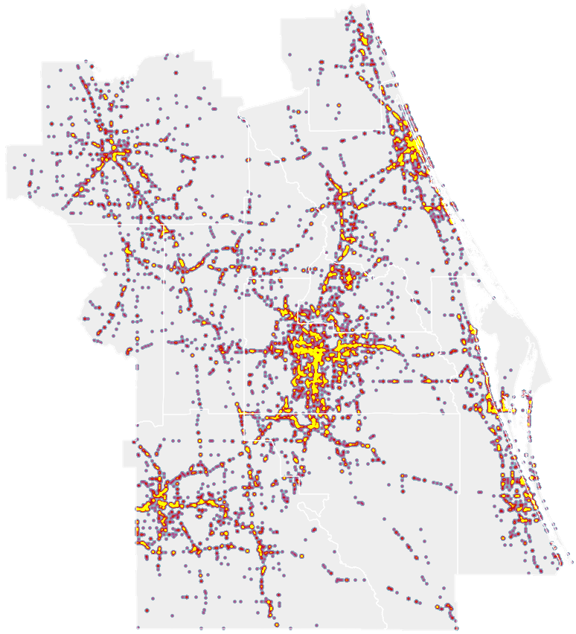
Fatal Automobile-Involved
Crash Hot Spots
2012-2021
Bicyclist-and-Pedestrian-Involved Crashes
The tables and chart below summarize bicyclist-and-pedestrian-involved crashes in the Central Florida MPO Alliance region. Overall, there has been a general uptrend in the region since 2012, with a slight decrease in 2016 and a sharp decrease in 2020.²⁸

Bike-Ped-Involved Crashes | 2017 | 2018 | 2019 | 2020 | 2021 | Total
 |  |  |  |  |  | 2017-2021
Brevard County | 525 | 548 | 508 | 480 | 528 | 2,589
Flagler County* | 49 | 59 | 70 | 66 | 74 | 318
Lake County | 194 | 173 | 204 | 196 | 221 | 988
Marion County | 242 | 214 | 251 | 218 | 211 | 1,136
Orange County | 1,305 | 1,299 | 1,293 | 994 | 1,091 | 5,982
Osceola County | 245 | 246 | 279 | 232 | 262 | 1,264
Polk County | 511 | 508 | 549 | 505 | 560 | 2,633
Seminole County | 313 | 329 | 343 | 327 | 386 | 1,698
Sumter County | 45 | 50 | 60 | 71 | 81 | 307
Volusia County | 554 | 592 | 578 | 536 | 621 | 2,881
CFMPOA Region | 3,983 | 4,018 | 4,135 | 3,625 | 4,035 | 19,796
* Portions of Flagler County are not included in the CFMPOA Alliance region. This table includes all of Flagler County
Source(s): Signal 4 Analytics
Bike-Ped-Involved Crashes | 2017 | 2018 | 2019 | 2020 | 2021 | Total
 |  |  |  |  |  | 2017-2021
Lake-Sumter MPO | 239 | 223 | 264 | 267 | 302 | 1,295
MetroPlan Orlando | 1,863 | 1,874 | 1,915 | 1,553 | 1,739 | 8,944
Ocala Marion TPO | 242 | 214 | 251 | 218 | 211 | 1,136
Polk TPO | 511 | 508 | 549 | 505 | 560 | 2,633
River to Sea TPO* | 603 | 651 | 648 | 602 | 695 | 3,199
Space Coast TPO | 525 | 548 | 508 | 480 | 528 | 2,589
* Portions of Flagler County are not included in the CFMPOA Alliance region. This table includes all of Flagler County
Source(s): Signal 4 Analytics
Fatal Bicyclist-and-Pedestrian-Involved Crashes
The tables and chart below summarize fatal bicyclist-and-pedestrian-involved crashes in the Central Florida MPO Alliance region. Overall, the trend is increasing and nearly doubled from 2012 to 2021.²⁸

Fatal Bike-Ped-Involved Crashes | 2017 | 2018 | 2019 | 2020 | 2021 | Total
 |  |  |  |  |  | 2017-2021
Brevard County | 26 | 19 | 20 | 19 | 34 | 118
Flagler County* | 3 | 2 | 1 | 3 | 3 | 12
Lake County | 6 | 13 | 16 | 11 | 7 | 53
Marion County | 20 | 15 | 22 | 24 | 22 | 103
Orange County | 70 | 60 | 66 | 52 | 86 | 334
Osceola County | 16 | 12 | 21 | 13 | 7 | 69
Polk County | 20 | 25 | 29 | 29 | 36 | 139
Seminole County | 17 | 8 | 13 | 13 | 10 | 61
Sumter County | 1 | 5 | 3 | 4 | 5 | 18
Volusia County | 31 | 36 | 29 | 37 | 37 | 170
CFMPOA Region | 210 | 195 | 220 | 205 | 247 | 1,077
* Portions of Flagler County are not included in the CFMPOA Alliance region. This table includes all of Flagler County
Source(s): Signal 4 Analytics
Fatal Bike-Ped-Involved Crashes | 2017 | 2018 | 2019 | 2020 | 2021 | Total
 |  |  |  |  |  | 2017-2021
Lake-Sumter MPO | 7 | 18 | 19 | 15 | 12 | 71
MetroPlan Orlando | 103 | 80 | 100 | 78 | 103 | 464
Ocala Marion TPO | 20 | 15 | 22 | 24 | 22 | 103
Polk TPO | 20 | 25 | 29 | 29 | 36 | 139
River to Sea TPO* | 34 | 38 | 30 | 40 | 40 | 182
Space Coast TPO | 26 | 19 | 20 | 19 | 34 | 118
* Portions of Flagler County are not included in the CFMPOA Alliance region. This table includes all of Flagler County
Source(s): Signal 4 Analytics
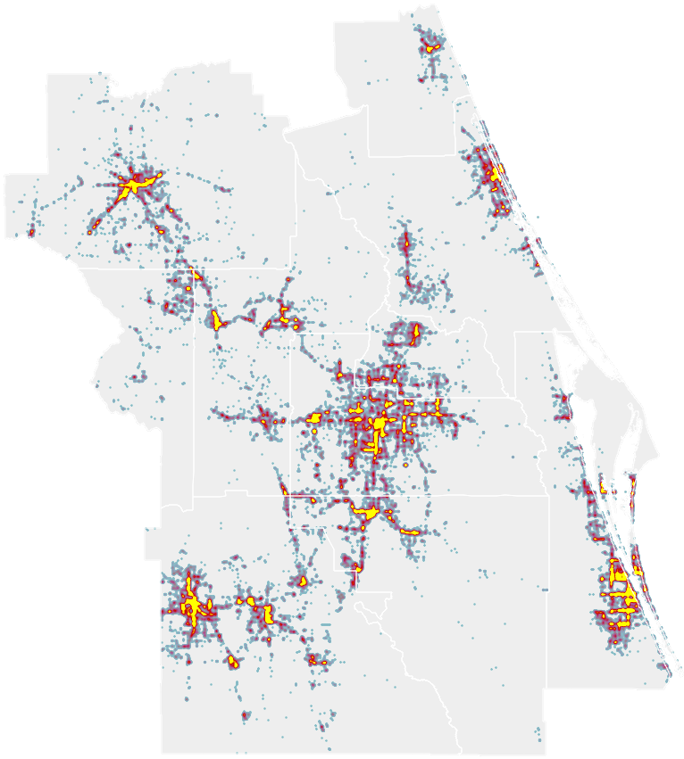
Bicycle-and-Pedestrian
Involved Crash Hot Spots
2012-2021
4.2 | Air Quality

Air pollution is associated with several health issues, including asthma, heart disease, and cancer. Ground-level ozone, for which motor vehicle emissions are a primary source, is an important issue to stakeholders in the Central Florida region.

In 2015, the Environmental Protection Agency (EPA) revised the standard for ozone from 75 parts per billion to 70 parts per billion during any eight-hour period. An area is considered as nonattainment (not meeting the standard) if the average of the annual fourth-highest ozone readings at any monitoring site for the three-year period equals or exceeds the 70 parts per billion standard.²⁹

The following table shows the fourth-highest eight-hour average reading, shown in parts per billion, for ozone monitoring sites in the Central Florida MPO Alliance Region from 2017 through 2021. The chart shows an overall downward trend in ozone levels from 2017 to 2021.²⁹

Ozone Levels (Parts Per Billion) | 2017 | 2018 | 2019 | 2020 | 2021 | Average
Melbourne (Brevard) | 61 | 55 | 48 | 58 | 59 | 56.2
Freedom 7 Elementary (Brevard) | 61 | 64 | 58 | 58 | 59 | 60.0
Sawgrass Road, Bunnell (Flagler) | 60 | 60 | 56 | 53 | 56 | 57.0
1901 Johns Lake Road (Lake) | 68 | 65 | 67 | 62 | 60 | 64.4
Ocala YMCA (Marion) | 64 | 62 | 62 | 61 | 63 | 62.4
County Impound (Marion) | 59 | 62 | 59 | 57 | 58 | 59.0
Lake Isles Estates (Orange) | 65 | 63 | 65 | 62 | 60 | 63.0
Four Corners (Osceola) | 67 | 67 | 72 | 60 | 62 | 65.6
Sikes Elementary (Polk) | 72 | 65 | 66 | 61 | 61 | 65.0
Baptist Children's Home (Polk) | 71 | 66 | 67 | 62 | 59 | 65.0
Seminole State (Seminole) | 67 | 64 | 62 | 60 | 62 | 63.0
Daytona Blind Service (Volusia) | 62 | 64 | 56 | 59 | 57 | 59.6
Average | 64.8 | 63.1 | 61.5 | 59.4 | 59.7 | 61.7
* Portions of Flagler County are not included in the CFMPOA Alliance region. This table includes all of Flagler County
Source(s): Florida Department of Environmental Protection
Air Quality Index (AQI)
The Air Quality Index (AQI) is a 0 to 500 score that measures overall air quality from air quality monitoring stations around the United States. The national standard for ‘satisfactory’ air quality as part of this index is a score of 100. The Air Quality Index measures five major air pollutants that are regulated by the Clean Air Act. These pollutants include ground-level ozone, particle pollution (PM 2.5 and PM 10), carbon monoxide, sulfur dioxide, and nitrogen dioxide.

The map below shows the Air Quality Index for 13 monitoring stations in the Central Florida MPO Alliance region as of November 26, 2022.³⁰
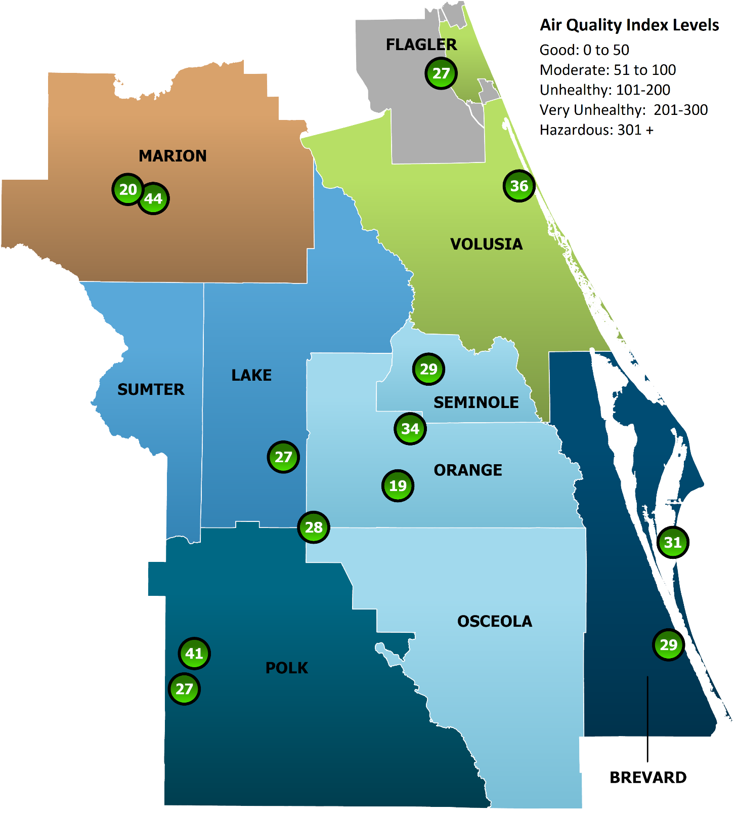
Air Quality Index
November 26, 2022

Environmental justice Areas (EJA’s)
Environmental Justice Areas are part of the Federal Government’s Justice 40 Initiative, which aims to direct 40% of the benefits of specified Federal Government investments to areas that are underserved, marginalized, and burdened by pollution. Environmental Justice Areas are areas that have been identified for environmental justice investment using a multi-faceted analysis of demographic and environmental conditions. The following map depicts the Central Florida MPO Alliance region’s Environmental Justice Areas in black.³¹

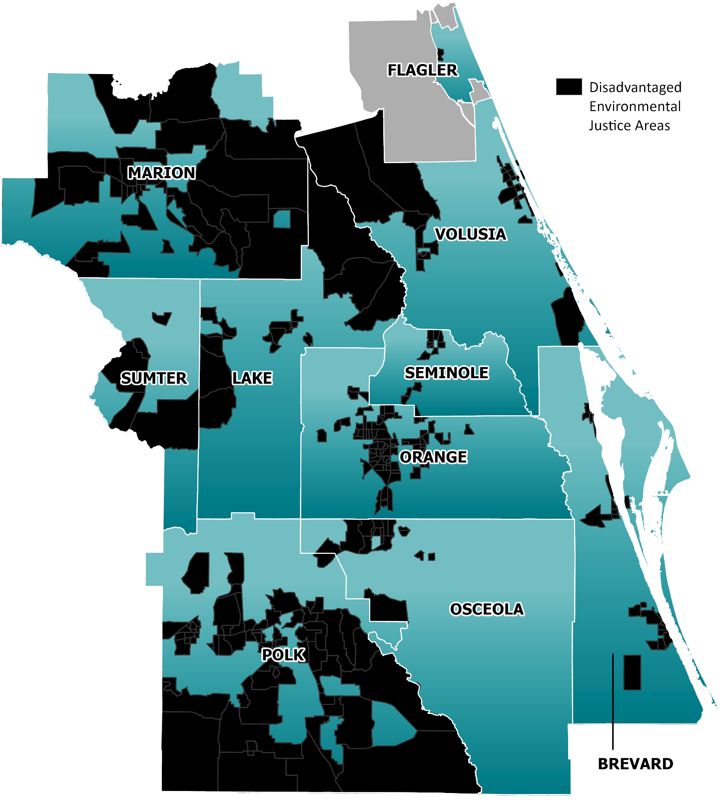
Disadvantaged Environmental
Justice Census Tracts
4.3 | Transportation System Usage, Reliability & Congestion

This chapter of the report provides analysis on trends impacting the overall reliability and experience that residents and visitors encounter on the state highway system.

Transportation Usage, Reliability & Congestion Indicators
The Florida Department of Transportation Source Book was used to compile information on the Central Florida MPO Alliance region’s roadway network. The seven indicators below are included in this section of the report.

- Vehicle Miles Traveled
- Vehicle Hours of Delay
- Planning Time Index
- Percent of Travel that is Heavily Congested
- Percent of Roadway Miles Heavily Congested
- Percent of the Time Roadways are Heavily Congested
- Duration of Congestion in Minutes

While there are some deviations, five of the seven indicators analyzed as part of this section are applicable to the State Highway System (SHS), shown in dark red in the map below.
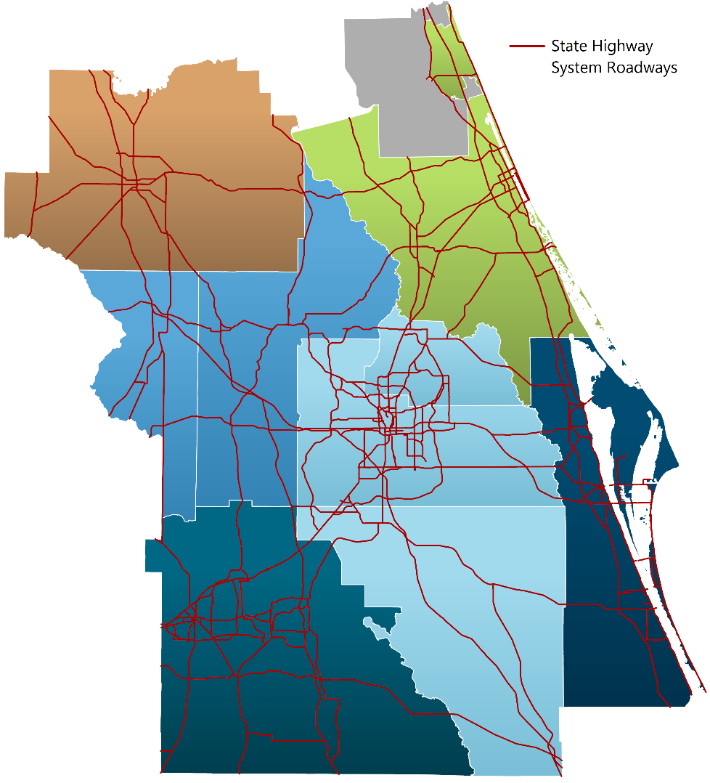
Vehicle Miles Traveled
Daily; National & State Highway Systems, Strategic Intermodal System

Vehicle Miles Traveled measures the average total miles traveled daily on the National and State Highway System and the Strategic Intermodal System.³²

Vehicle Miles Traveled | 2016 | 2017 | 2018 | 2019 | 2020
 | Daily VMT | Daily VMT | Daily VMT | Daily VMT | Daily VMT
Brevard County | 23,306,081 | 24,265,150 | 24,619,495 | 25,052,422 | 23,379,402
Flagler County* | 4,436,123 | 4,371,214 | 4,667,825 | 5,054,422 | 5,153,828
Lake County | 11,372,541 | 11,968,426 | 12,028,962 | 12,621,391 | 12,119,496
Marion County | 14,441,171 | 14,695,673 | 15,156,092 | 16,500,543 | 15,438,596
Orange County | 54,346,791 | 56,792,025 | 58,275,168 | 61,760,821 | 56,424,034
Osceola County | 14,169,152 | 14,866,319 | 15,294,315 | 15,662,991 | 13,719,952
Polk County | 27,633,131 | 28,136,840 | 29,019,214 | 29,228,668 | 27,052,315
Seminole County | 13,647,022 | 14,125,332 | 14,258,743 | 14,115,033 | 13,255,578
Sumter County | 7,595,335 | 8,017,999 | 8,429,795 | 8,878,830 | 7,973,667
Volusia County | 22,177,130 | 21,942,573 | 22,639,148 | 24,049,165 | 23,813,719
CFMPOA Region | 193,124,477 | 199,181,551 | 204,388,757 | 212,924,286 | 198,330,587
* Portions of Flagler County are not included in the CFMPOA Alliance region. This table includes all of Flagler County
Source(s): Florida Dept. of Transportation (Latest Release)
Vehicle Miles Traveled | 2016 | 2017 | 2018 | 2019 | 2020
 | Daily VMT | Daily VMT | Daily VMT | Daily VMT | Daily VMT
Lake-Sumter MPO | 18,967,876 | 19,986,425 | 20,458,757 | 21,500,221 | 20,093,163
MetroPlan Orlando | 82,162,965 | 85,783,676 | 87,828,226 | 91,538,845 | 83,399,564
Ocala Marion TPO | 14,441,171 | 14,695,673 | 15,156,092 | 16,500,543 | 15,438,596
Polk TPO | 27,633,131 | 28,136,840 | 29,019,214 | 29,228,668 | 27,052,315
River to Sea TPO* | 26,613,253 | 26,313,787 | 27,306,973 | 29,103,587 | 28,967,547
Space Coast TPO | 23,306,081 | 24,265,150 | 24,619,495 | 25,052,422 | 23,379,402
* Portions of Flagler County are not included in the CFMPOA Alliance region. This table includes all of Flagler County
Source(s): Florida Dept. of Transportation (Latest Release)
Vehicle Hours of Delay
Peak Hour; National Highway System, State Highway System, and Strategic Intermodal System

Vehicle hours of delay measures the “additional travel time” experienced by motorists beyond normal travel conditions without congestion.³³

Vehicle Hours of Delay | 2016 | 2017 | 2018 | 2019 | 2020 | 2016-20
Peak Hour |  |  |  |  |  | Average
Brevard County | 1,408 | 2,124 | 1,785 | 1,922 | 1,017 | 1,651
Flagler County* | 64 | 64 | 62 | 79 | 78 | 69
Lake County | 357 | 554 | 692 | 781 | 495 | 576
Marion County | 648 | 1,116 | 1,083 | 1,192 | 773 | 962
Orange County | 26,053 | 30,650 | 31,091 | 31,623 | 12,034 | 26,290
Osceola County | 3,843 | 5,711 | 7,020 | 7,903 | 3,663 | 5,628
Polk County | 1,907 | 2,423 | 2,609 | 2,937 | 1,904 | 2,356
Seminole County | 4,943 | 6,336 | 5,979 | 5,851 | 2,513 | 5,124
Sumter County | 140 | 348 | 311 | 246 | 160 | 241
Volusia County | 1,729 | 2,464 | 2,239 | 2,301 | 1,537 | 2,054
CFMPOA Region | 41,092 | 51,790 | 52,871 | 54,835 | 24,174 | 44,952
* Portions of Flagler County are not included in the CFMPOA Alliance region. This table includes all of Flagler County
Source(s): Florida Dept. of Transportation, HERE Technologies
Vehicle Hours of Delay | 2016 | 2017 | 2018 | 2019 | 2020 | 2016-20
Peak Hour |  |  |  |  |  | Average
Lake-Sumter MPO | 497 | 902 | 1,003 | 1,027 | 655 | 817
MetroPlan Orlando | 34,839 | 42,697 | 44,090 | 45,377 | 18,210 | 37,043
Ocala Marion TPO | 648 | 1,116 | 1,083 | 1,192 | 773 | 962
Polk TPO | 1,907 | 2,423 | 2,609 | 2,937 | 1,904 | 2,356
River to Sea TPO* | 1,793 | 2,528 | 2,301 | 2,380 | 1,615 | 2,123
Space Coast TPO | 1,408 | 2,124 | 1,785 | 1,922 | 1,017 | 1,651
* Portions of Flagler County are not included in the CFMPOA Alliance region. This table includes all of Flagler County
Source(s): Florida Dept. of Transportation, HERE Technologies
Planning Time Index
Peak Hour, State Highway System

Planning Time Index measures the extent of a travel delay versus normal travel conditions, where a value of 1.00 equals normal travel time. Higher values represent greater delays.³⁴

Planning Time Index | 2016 | 2017 | 2018 | 2019 | 2020 | 2016-20
Peak Hour |  |  |  |  |  | Average
Brevard County | 1.16 | 1.19 | 1.20 | 1.21 | 1.17 | 1.19
Flagler County* | 1.11 | 1.11 | 1.12 | 1.15 | 1.13 | 1.12
Lake County | 1.18 | 1.22 | 1.24 | 1.25 | 1.22 | 1.22
Marion County | 1.17 | 1.28 | 1.28 | 1.32 | 1.21 | 1.25
Orange County | 1.58 | 1.70 | 1.72 | 1.77 | 1.52 | 1.66
Osceola County | 1.34 | 1.42 | 1.46 | 1.47 | 1.44 | 1.43
Polk County | 1.22 | 1.27 | 1.29 | 1.32 | 1.27 | 1.27
Seminole County | 1.62 | 1.81 | 1.80 | 1.86 | 1.55 | 1.73
Sumter County | 1.09 | 1.12 | 1.15 | 1.12 | 1.10 | 1.12
Volusia County | 1.18 | 1.20 | 1.21 | 1.20 | 1.18 | 1.19
CFMPOA Region | 1.34 | 1.42 | 1.43 | 1.46 | 1.34 | 1.40
* Portions of Flagler County are not included in the CFMPOA Alliance region. This table includes all of Flagler County
Source(s): Florida Dept. of Transportation, HERE Technologies
Planning Time Index | 2016 | 2017 | 2018 | 2019 | 2020 | 2016-20
Peak Hour |  |  |  |  |  | Average
Lake-Sumter MPO | 1.16 | 1.19 | 1.22 | 1.22 | 1.19 | 1.19
MetroPlan Orlando | 1.55 | 1.67 | 1.69 | 1.74 | 1.51 | 1.63
Ocala Marion TPO | 1.17 | 1.28 | 1.28 | 1.32 | 1.21 | 1.25
Polk TPO | 1.22 | 1.27 | 1.29 | 1.32 | 1.27 | 1.27
River to Sea TPO* | 1.17 | 1.18 | 1.19 | 1.19 | 1.17 | 1.18
Space Coast TPO | 1.16 | 1.19 | 1.20 | 1.21 | 1.17 | 1.19
* Portions of Flagler County are not included in the CFMPOA Alliance region. This table includes all of Flagler County
Source(s): Florida Dept. of Transportation, HERE Technologies
Percent of Travel that is Heavily Congested
Peak Hour, State Highway System

This metric uses vehicle miles traveled and average travel speeds to determine the percentage of travel time that qualifies under the FDOT definition of “heavily congested”.³⁵

% Travel Heavily Congested | 2016 | 2017 | 2018 | 2019 | 2020 | 2016-20
Peak Hour |  |  |  |  |  | Average
Brevard County | 0.7% | 1.2% | 1.0% | 1.4% | 0.6% | 1.0%
Flagler County* | 0.4% | 0.2% | 0.3% | 0.6% | 0.5% | 0.4%
Lake County | 0.5% | 1.0% | 1.6% | 1.3% | 0.5% | 1.0%
Marion County | 1.2% | 2.2% | 2.1% | 2.8% | 1.2% | 1.9%
Orange County | 14.7% | 17.7% | 17.2% | 17.5% | 6.5% | 14.7%
Osceola County | 7.9% | 11.1% | 12.6% | 13.7% | 7.4% | 10.5%
Polk County | 1.3% | 2.0% | 2.1% | 2.7% | 1.6% | 1.9%
Seminole County | 9.2% | 11.7% | 11.3% | 12.7% | 4.8% | 9.9%
Sumter County | 0.9% | 1.7% | 1.7% | 1.7% | 0.6% | 1.3%
Volusia County | 1.0% | 1.6% | 1.4% | 1.5% | 1.0% | 1.3%
CFMPOA Region | 5.9% | 7.6% | 7.5% | 8.0% | 3.3% | 6.5%
* Portions of Flagler County are not included in the CFMPOA Alliance region. This table includes all of Flagler County
Source(s): Florida Dept. of Transportation, HERE Technologies
% Travel Heavily Congested | 2016 | 2017 | 2018 | 2019 | 2020 | 2016-20
Peak Hour |  |  |  |  |  | Average
Lake-Sumter MPO | 0.6% | 1.2% | 1.6% | 1.4% | 0.5% | 1.1%
MetroPlan Orlando | 12.4% | 15.3% | 15.2% | 15.8% | 6.3% | 13.0%
Ocala Marion TPO | 1.2% | 2.2% | 2.1% | 2.8% | 1.2% | 1.9%
Polk TPO | 1.3% | 2.0% | 2.1% | 2.7% | 1.6% | 1.9%
River to Sea TPO* | 0.9% | 1.4% | 1.2% | 1.3% | 0.9% | 1.1%
Space Coast TPO | 0.7% | 1.2% | 1.0% | 1.4% | 0.6% | 1.0%
* Portions of Flagler County are not included in the CFMPOA Alliance region. This table includes all of Flagler County
Source(s): Florida Dept. of Transportation, HERE Technologies
Percent of Roadway Miles Heavily Congested
Peak Hour, State Highway System

This metric quantifies the percent of roadway miles on the State Highway System that qualify under the FDOT definition of “heavily congested”.³⁶

% Miles Heavily Congested | 2016 | 2017 | 2018 | 2019 | 2020 | 2016-20
Peak Hour |  |  |  |  |  | Average
Brevard County | 0.5% | 1.0% | 0.9% | 1.1% | 0.6% | 0.8%
Flagler County* | 0.2% | 0.2% | 0.2% | 0.3% | 0.3% | 0.2%
Lake County | 0.5% | 0.8% | 1.4% | 1.2% | 0.6% | 0.9%
Marion County | 0.5% | 1.0% | 1.0% | 1.2% | 0.5% | 0.8%
Orange County | 9.7% | 12.3% | 11.7% | 12.2% | 4.8% | 10.1%
Osceola County | 2.7% | 4.3% | 4.9% | 5.5% | 2.7% | 4.0%
Polk County | 0.9% | 1.4% | 1.4% | 1.7% | 1.2% | 1.3%
Seminole County | 5.1% | 7.1% | 7.1% | 8.1% | 3.4% | 6.2%
Sumter County | 0.5% | 0.8% | 0.8% | 0.8% | 0.3% | 0.6%
Volusia County | 0.7% | 1.3% | 1.3% | 1.4% | 0.9% | 1.1%
CFMPOA Region | 3.6% | 4.9% | 4.8% | 5.2% | 2.2% | 4.2%
* Portions of Flagler County are not included in the CFMPOA Alliance region. This table includes all of Flagler County
Source(s): Florida Dept. of Transportation, HERE Technologies
% Miles Heavily Congested | 2016 | 2017 | 2018 | 2019 | 2020 | 2016-20
Peak Hour |  |  |  |  |  | Average
Lake-Sumter MPO | 0.5% | 0.8% | 1.2% | 1.1% | 0.5% | 0.8%
MetroPlan Orlando | 7.5% | 9.8% | 9.6% | 10.2% | 4.1% | 8.3%
Ocala Marion TPO | 0.5% | 1.0% | 1.0% | 1.2% | 0.5% | 0.8%
Polk TPO | 0.9% | 1.4% | 1.4% | 1.7% | 1.2% | 1.3%
River to Sea TPO* | 0.6% | 1.1% | 1.1% | 1.2% | 0.8% | 1.0%
Space Coast TPO | 0.5% | 1.0% | 0.9% | 1.1% | 0.6% | 0.8%
* Portions of Flagler County are not included in the CFMPOA Alliance region. This table includes all of Flagler County
Source(s): Florida Dept. of Transportation, HERE Technologies
Percent of the Time Roadways are Heavily Congested
Daily, State Highway System

This metric quantifies the percent of the time that roadways on the State Highway System qualify under the FDOT definition of “heavily congested”.³⁷

% Time Heavily Congested | 2016 | 2017 | 2018 | 2019 | 2020 | 2016-20
Daily |  |  |  |  |  | Average
Brevard County | 0.2% | 0.4% | 0.4% | 0.5% | 0.2% | 0.3%
Flagler County* | 0.1% | 0.2% | 0.1% | 0.5% | 0.4% | 0.3%
Lake County | 0.2% | 0.3% | 0.8% | 0.6% | 0.5% | 0.5%
Marion County | 0.2% | 0.4% | 0.3% | 0.4% | 0.2% | 0.3%
Orange County | 2.3% | 3.0% | 3.0% | 3.2% | 1.6% | 2.6%
Osceola County | 0.8% | 1.3% | 1.6% | 1.6% | 0.8% | 1.2%
Polk County | 0.4% | 0.7% | 0.7% | 0.8% | 0.6% | 0.6%
Seminole County | 1.0% | 1.5% | 1.4% | 1.8% | 1.1% | 1.4%
Sumter County | 0.5% | 0.5% | 0.5% | 0.6% | 0.2% | 0.5%
Volusia County | 0.4% | 0.6% | 0.6% | 0.8% | 0.6% | 0.6%
CFMPOA Region | 0.9% | 1.3% | 1.4% | 1.5% | 0.8% | 1.2%
* Portions of Flagler County are not included in the CFMPOA Alliance region. This table includes all of Flagler County
Source(s): Florida Dept. of Transportation, HERE Technologies
% Time Heavily Congested | 2016 | 2017 | 2018 | 2019 | 2020 | 2016-20
Daily |  |  |  |  |  | Average
Lake-Sumter MPO | 0.3% | 0.4% | 0.7% | 0.6% | 0.4% | 0.5%
MetroPlan Orlando | 1.8% | 2.4% | 2.4% | 2.6% | 1.4% | 2.1%
Ocala Marion TPO | 0.2% | 0.4% | 0.3% | 0.4% | 0.2% | 0.3%
Polk TPO | 0.4% | 0.7% | 0.7% | 0.8% | 0.6% | 0.6%
River to Sea TPO* | 0.3% | 0.5% | 0.5% | 0.7% | 0.6% | 0.5%
Space Coast TPO | 0.2% | 0.4% | 0.4% | 0.5% | 0.2% | 0.3%
* Portions of Flagler County are not included in the CFMPOA Alliance region. This table includes all of Flagler County
Source(s): Florida Dept. of Transportation, HERE Technologies
Duration of Congestion in Minutes
Daily, State Highway System

This metric quantifies the average duration of time, in minutes, that roadways with 15 minutes or more per hour of congestion on the State Highway System are heavily congested.³⁸

Duration of Congestion | 2016 | 2017 | 2018 | 2019 | 2020 | 2016-20
Daily, in Minutes |  |  |  |  |  | Average
Brevard County | 2.03 | 4.95 | 4.61 | 7.48 | 2.26 | 4.27
Flagler County* | 1.88 | 1.21 | 0.36 | 14.12 | 9.75 | 5.46
Lake County | 2.23 | 3.96 | 22.31 | 9.48 | 6.54 | 8.90
Marion County | 4.10 | 8.12 | 6.51 | 9.49 | 2.70 | 6.18
Orange County | 49.99 | 62.00 | 59.96 | 68.21 | 32.17 | 54.47
Osceola County | 19.58 | 31.60 | 40.16 | 46.40 | 23.09 | 32.17
Polk County | 8.06 | 13.82 | 15.39 | 20.65 | 12.15 | 14.01
Seminole County | 29.61 | 39.95 | 34.33 | 39.82 | 17.14 | 32.17
Sumter County | 10.36 | 12.25 | 10.22 | 16.09 | 3.25 | 10.43
Volusia County | 5.66 | 9.39 | 8.57 | 11.86 | 8.82 | 8.86
CFMPOA Region | 20.41 | 27.52 | 28.41 | 32.77 | 15.93 | 25.01
* Portions of Flagler County are not included in the CFMPOA Alliance region. This table includes all of Flagler County
Source(s): Florida Dept. of Transportation, HERE Technologies
Duration of Congestion | 2016 | 2017 | 2018 | 2019 | 2020 | 2016-20
Daily, in Minutes |  |  |  |  |  | Average
Lake-Sumter MPO | 4.30 | 6.08 | 19.22 | 11.17 | 5.70 | 9.29
MetroPlan Orlando | 40.48 | 52.15 | 51.24 | 58.57 | 27.50 | 45.98
Ocala Marion TPO | 4.10 | 8.12 | 6.51 | 9.49 | 2.70 | 6.18
Polk TPO | 8.06 | 13.82 | 15.39 | 20.65 | 12.15 | 14.01
River to Sea TPO* | 4.99 | 7.95 | 7.12 | 12.26 | 8.98 | 8.26
Space Coast TPO | 2.03 | 4.95 | 4.61 | 7.48 | 2.26 | 4.27
* Portions of Flagler County are not included in the CFMPOA Alliance region. This table includes all of Flagler County
Source(s): Florida Dept. of Transportation, HERE Technologies
Freight – Average Truck Speed
Peak Hour; State Highway System

Avg. Truck Speed | 2016 | 2017 | 2018 | 2019 | 2020 | 2016-20
Miles Per Hour |  |  |  |  |  | Average
Brevard County | 60.9 | 61.0 | 61.0 | 61.1 | 61.5 | 61.1
Flagler County* | 63.0 | 62.3 | 63.1 | 61.6 | 59.7 | 61.9
Lake County | 50.7 | 49.5 | 51.0 | 50.9 | 50.8 | 50.6
Marion County | 60.7 | 59.8 | 60.9 | 61.6 | 62.4 | 61.1
Orange County | 50.0 | 49.0 | 48.9 | 49.3 | 54.6 | 50.4
Osceola County | 56.8 | 55.9 | 56.6 | 56.7 | 57.7 | 56.7
Polk County | 54.5 | 54.6 | 55.0 | 53.8 | 54.6 | 54.5
Seminole County | 47.4 | 47.1 | 47.2 | 47.2 | 49.8 | 47.7
Sumter County | 62.1 | 62.2 | 62.5 | 63.4 | 65.1 | 63.1
Volusia County | 57.7 | 58.3 | 58.9 | 59.1 | 60.0 | 58.8
CFMPOA Region | 54.5 | 54.0 | 54.4 | 54.4 | 56.5 | 54.8
* Portions of Flagler County are not included in the CFMPOA Alliance region. This table includes all of Flagler County
Source(s): Florida Dept. of Transportation, HERE Technologies³⁹
Avg. Truck Speed | 2016 | 2017 | 2018 | 2019 | 2020 | 2016-20
Miles Per Hour |  |  |  |  |  | Average
Lake-Sumter MPO | 53.6 | 52.7 | 53.9 | 54.1 | 54.4 | 53.8
MetroPlan Orlando | 50.7 | 49.8 | 49.9 | 50.2 | 54.2 | 50.9
Ocala Marion TPO | 60.7 | 59.8 | 60.9 | 61.6 | 62.4 | 61.1
Polk TPO | 54.5 | 54.6 | 55.0 | 53.8 | 54.6 | 54.5
River to Sea TPO* | 58.6 | 59.0 | 59.6 | 59.5 | 59.9 | 59.4
Space Coast TPO | 60.9 | 61.0 | 61.0 | 61.1 | 61.5 | 61.1
* Portions of Flagler County are not included in the CFMPOA Alliance region. This table includes all of Flagler County
Source(s): Florida Dept. of Transportation, HERE Technologies³⁹

Freight – Truck Hours of Delay
Daily; National Highway System, State Highway System, and Strategic Intermodal System

Truck Hours of Delay | 2016 | 2017 | 2018 | 2019 | 2020 | 2016-20
Daily, in Minutes |  |  |  |  |  | Average
Brevard County | 314 | 418 | 440 | 570 | 339 | 416
Flagler County* | 25 | 29 | 40 | 73 | 36 | 41
Lake County | 139 | 191 | 286 | 322 | 235 | 235
Marion County | 387 | 598 | 671 | 858 | 459 | 595
Orange County | 2,950 | 3,203 | 3,610 | 3,687 | 1,634 | 3,017
Osceola County | 691 | 1,357 | 1,831 | 1,836 | 884 | 1,320
Polk County | 623 | 870 | 1,197 | 1,334 | 689 | 943
Seminole County | 493 | 617 | 684 | 606 | 299 | 540
Sumter County | 273 | 485 | 435 | 516 | 222 | 386
Volusia County | 407 | 495 | 525 | 533 | 391 | 470
CFMPOA Region | 6,302 | 8,263 | 9,719 | 10,335 | 5,188 | --
* Portions of Flagler County are not included in the CFMPOA Alliance region. This table includes all of Flagler County
Source(s): Florida Dept. of Transportation, HERE Technologies40
Truck Hours of Delay | 2016 | 2017 | 2018 | 2019 | 2020 | 2016-20
Daily, in Minutes |  |  |  |  |  | Average
Lake-Sumter MPO | 412 | 676 | 721 | 838 | 457 | 621
MetroPlan Orlando | 4,134 | 5,177 | 6,125 | 6,129 | 2,817 | 4,876
Ocala Marion TPO | 387 | 598 | 671 | 858 | 459 | 595
Polk TPO | 623 | 870 | 1,197 | 1,334 | 689 | 943
River to Sea TPO* | 432 | 524 | 565 | 606 | 427 | 511
Space Coast TPO | 314 | 418 | 440 | 570 | 339 | 416
* Portions of Flagler County are not included in the CFMPOA Alliance region. This table includes all of Flagler County
Source(s): Florida Dept. of Transportation, HERE Technologies40
4.4 | E-Commerce & Remote Work

E-Commerce and remote work will have future implications on travel trends as more purchases are made online, more people are working from home, and less people are using the state transportation system to get to work or to make purchases. This section of the report identifies critical trends that are occurring across the following indicators:

- Historic Department Store & Electronic Shopping Employment
- Percent of Florida Residents Working from Home
- Percent of Retail Purchases Made Online

Historic Department Store & Electronic Shopping Employment
A clear trend has formed in retail employment, with a consistent increase in electronic shopping employment and accelerating decrease in department store employment.⁴¹ Most notably, department store employment saw a large decrease in 2020 as the COVID-19 pandemic closed many brick-and-mortar businesses.

Source: U.S. Bureau of Labor Statistics, Hours and Earnings Survey
Percent of Florida Residents Working from Home
Following consistent rates of employees working from home from 2016 to 2019, a substantial jump in work from home rates occurred in 2020 with the onset of the COVID-19 pandemic.⁴² While numerous employers are beginning to open offices, it remains to be seen if this trend will reverse, and if there is a reverse, if it will fall back to pre-COVID-19 levels. Following this metric closely as new data is released is a high priority for the Central Florida MPO Alliance.

Source: U.S Census Bureau, FDOT 2021 Resident Satisfaction Survey

Percent of Retail Purchases Made Online
The trend in purchasing continues to move to the digital world as e-commerce accrues a larger percentage of the retail market. The chart below shows an accelerating share of retail purchases being completed online from 2013 to 2021.⁴³
Source: Statista
4.5 | Electric Vehicles & Fuel Consumption

This section of the report provides information on the rapidly-changing landscape marked by the rapid, nationwide adoption of electric vehicles, and summarizes regional trends relating to gasoline and diesel fuel consumption.

Funding Implications of Electric Vehicle Market Share & Increasing Vehicle Miles Traveled
Funding for roadway projects in the state of Florida is reliant on gas tax revenues, and it is unclear whether gasoline and diesel fuel demand will continue to increase into the future given the growing market share of electric vehicles. This factor, alongside the continuing trend of increased vehicle miles traveled (VMT) over time, means that fewer dollars will be available to fund roadways that are being used more heavily over time. This challenge will require more engagement between the Central Florida MPO Alliance and policymakers and stakeholders at the federal and state levels.

Electric Vehicle Adoption Rate
The chart below depicts the electric vehicle adoption rate in the United States from 2015 to 2021. During this time period, the market share of electric vehicles increased by five times, signaling the potential beginning of an exponential growth curve.⁴⁴

Source(s): Auto Manufacturers Alliance, Automotive News, InsideEVs.com
Electric Vehicle Charging Stations
As electric vehicle adoption accelerates, the need for infrastructure to support their usage is an important factor in overall scalability. The map below shows electric vehicle stations in the Central Florida MPO Alliance region as of December 4, 2022 as compiled by the U.S. Department of Transportation. There are currently 847 stations in the region.⁴⁵

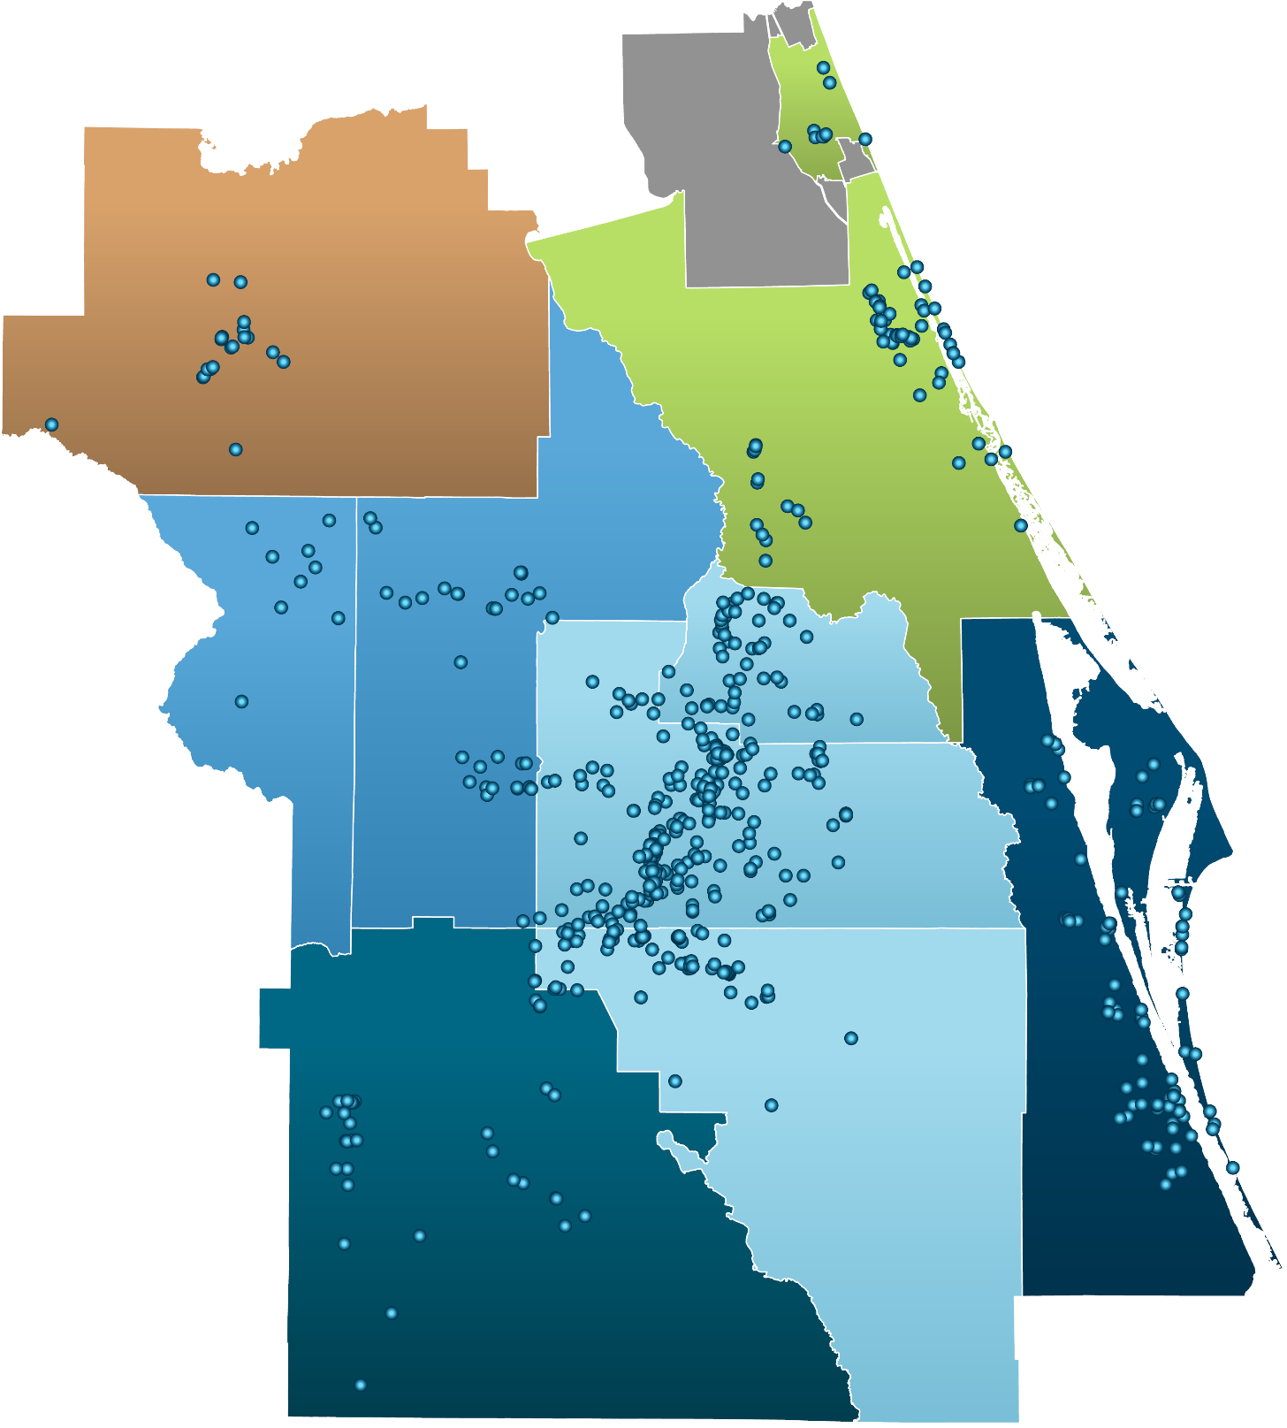
Electric Vehicle
Charging Stations

Gasoline Consumption
The tables and chart below depict the trend in gasoline consumption in the Alliance region.⁴⁶

Gasoline Consumption | 2016-17 | 2017-18 | 2018-19 | 2019-20 | 2020-21
 | Gallons | Gallons | Gallons | Gallons | Gallons
Brevard County | 259,014,856 | 263,674,585 | 269,240,362 | 250,055,588 | 247,284,877
Flagler County* | 41,718,997 | 43,958,293 | 44,550,218 | 42,021,226 | 44,626,840
Lake County | 143,875,036 | 147,079,506 | 149,293,977 | 143,409,141 | 144,969,098
Marion County | 173,252,447 | 175,540,794 | 181,722,854 | 178,531,967 | 181,332,876
Orange County | 675,785,007 | 687,389,037 | 709,390,547 | 644,126,888 | 602,771,769
Osceola County | 179,475,330 | 185,681,440 | 186,939,048 | 172,932,022 | 172,998,637
Polk County | 262,550,929 | 273,727,763 | 288,045,950 | 280,565,399 | 292,039,759
Seminole County | 206,503,106 | 208,464,340 | 210,061,056 | 191,903,490 | 179,891,244
Sumter County | 60,267,062 | 64,493,984 | 69,284,692 | 64,540,749 | 64,994,246
Volusia County | 232,104,685 | 238,844,285 | 242,658,779 | 229,864,485 | 233,913,819
CFMPOA Region | 2,234,547,455 | 2,288,854,027 | 2,351,187,483 | 2,197,950,955 | 2,164,823,165
* Portions of Flagler County are not included in the CFMPOA Alliance region. This table includes all of Flagler County
Source(s): Florida Department of Revenue
Gasoline Consumption | 2016-17 | 2017-18 | 2018-19 | 2019-20 | 2020-21
 | Gallons | Gallons | Gallons | Gallons | Gallons
Lake-Sumter MPO | 204,142,098 | 211,573,490 | 218,578,669 | 207,949,890 | 209,963,344
MetroPlan Orlando | 1,061,763,443 | 1,081,534,817 | 1,106,390,651 | 1,008,962,400 | 955,661,650
Ocala Marion TPO | 173,252,447 | 175,540,794 | 181,722,854 | 178,531,967 | 181,332,876
Polk TPO | 262,550,929 | 273,727,763 | 288,045,950 | 280,565,399 | 292,039,759
River to Sea TPO* | 273,823,682 | 282,802,578 | 287,208,997 | 271,885,711 | 278,540,659
Space Coast TPO | 259,014,856 | 263,674,585 | 269,240,362 | 250,055,588 | 247,284,877
* Portions of Flagler County are not included in the CFMPOA Alliance region. This table includes all of Flagler County
Source(s): Florida Department of Revenue

Diesel Fuel Consumption
The tables and chart below depict the trend in diesel fuel consumption in the Alliance region.⁴⁶

Diesel Consumption | 2016-17 | 2017-18 | 2018-19 | 2019-20 | 2020-21
 | Gallons | Gallons | Gallons | Gallons | Gallons
Brevard County | 137,871,185 | 136,285,659 | 179,364,275 | 194,640,059 | 187,607,808
Flagler County* | 5,315,176 | 5,383,944 | 5,408,199 | 5,608,554 | 5,373,593
Lake County | 18,457,909 | 18,971,612 | 18,682,221 | 19,319,359 | 18,947,992
Marion County | 48,381,187 | 51,135,315 | 51,069,048 | 53,691,953 | 52,920,882
Orange County | 121,846,733 | 127,681,128 | 125,483,597 | 130,502,713 | 126,006,096
Osceola County | 16,947,563 | 18,043,011 | 18,471,332 | 19,765,655 | 19,444,527
Polk County | 86,266,326 | 90,556,683 | 89,852,011 | 93,650,908 | 90,536,434
Seminole County | 21,504,735 | 22,146,478 | 21,892,897 | 19,279,029 | 18,440,013
Sumter County | 33,432,524 | 35,962,275 | 35,625,782 | 36,440,550 | 35,777,077
Volusia County | 29,592,017 | 31,448,444 | 31,653,540 | 33,048,196 | 32,103,868
CFMPOA Region | 519,615,355 | 537,614,549 | 577,502,902 | 605,946,976 | 587,158,290
* Portions of Flagler County are not included in the CFMPOA Alliance region. This table includes all of Flagler County
Source(s): Florida Department of Revenue
Diesel Consumption | 2016-17 | 2017-18 | 2018-19 | 2019-20 | 2020-21
 | Gallons | Gallons | Gallons | Gallons | Gallons
Lake-Sumter MPO | 51,890,433 | 54,933,887 | 54,308,003 | 55,759,909 | 54,725,069
MetroPlan Orlando | 160,299,031 | 167,870,617 | 165,847,826 | 169,547,397 | 163,890,636
Ocala Marion TPO | 48,381,187 | 51,135,315 | 51,069,048 | 53,691,953 | 52,920,882
Polk TPO | 86,266,326 | 90,556,683 | 89,852,011 | 93,650,908 | 90,536,434
River to Sea TPO* | 34,907,193 | 36,832,388 | 37,061,739 | 38,656,750 | 37,477,461
Space Coast TPO | 137,871,185 | 136,285,659 | 179,364,275 | 194,640,059 | 187,607,808
* Portions of Flagler County are not included in the CFMPOA Alliance region. This table includes all of Flagler County
Source(s): Florida Department of Revenue

Source: U.S. Energy Information Administration (2022)⁴⁷
4.6 | Autonomous Vehicles

This section of the report outlines some potential trends that will need to be monitored if autonomous vehicles begin to be adopted in the Central Florida MPO Alliance region.

VMT Implications
As autonomous vehicles are adopted, vehicle miles traveled (VMT) may increase as a result of additional trips on roadways consisting of automobiles without human drivers operating them. This could result from numerous step-changes in logistics technology, including autonomous vehicles being used for personal deliveries.

Surface Parking Demand Implications
Autonomous vehicles, without a driver, could potentially be used for more hours per day as a result of autonomous vehicle owners renting out their vehicles while they are at work or otherwise occupied. As a result, there could be a reduced number of stationary (parked) vehicles at any given point in time as those vehicles are being utilized by individuals who do not own a vehicle themselves.

Transportation Cost Implications
If autonomous vehicle adoption is scaled, cost savings for end users could be realized when compared to the current pricing of taxi services and phone applications such as Uber and Lyft. Potential reasons behind this cost saving could include 1) removing the requirement of a human driver to transport a person from point A to point B, and 2) costs savings on fuel consumption if the autonomous vehicles are simultaneously electric battery-powered.

Vision Zero (Safety) Implications
Depending on the accuracy, scalability and latency of artificial intelligence programs that make autonomous vehicles possible, autonomous vehicles could potentially operate more safely than human drivers who are prone to error, however this has not yet been definitively demonstrated. If such a feat in technological innovation is achieved, then motorist, motor vehicle occupant, bicyclist and pedestrian injuries and fatalities could be reduced.

Transportation Sector Employment Implications
As described in ‘Transportation Cost Implications’, removing the need for a driver could potentially reduce the workforce in the transportation and logistics sector. While the Federal Highway Administration and other agencies have not approved driverless trucks as of 2022, a pivot in this direction could greatly reduce the workforce in the aforementioned sectors.

Next Steps & Funding Opportunities

Members of the Central Florida MPO Alliance are busy at work identifying opportunities to improve the region’s multifaceted transportation network.

As such, numerous opportunities for funding from state and federal sources are available to MPO’s, counties and municipalities to improve their transportation systems. The Infrastructure Investment and Jobs Act that passed the U.S. Congress in 2022 will be a primary driver of funding for many years to come for the MPO Alliance. A key component of the Infrastructure Investment and Jobs Act is the Safe Streets and Roads for All program.

As part of this program, the Federal Government has released funding for MPO’s and municipalities to develop action plans to improve roadway safety for all users in their communities. During the 2023 grant period, the following Central Florida MPO’s and municipalities received funding for action plan development and implementation:

- City of Mount Dora – SS4A Action Plan
- Lake County – SS4A Action Plan
- MetroPlan Orlando – SS4A Action Plan
- Polk County – Safer Roads FL Action Plan
- River To Sea TPO – Comprehensive Safety Action Plan

Conclusion

The Central Florida MPO Alliance will continue to convene and collaborate to address shared issues that impact residents and visitors of the Central Florida region.

In addition to completing this report, the Central Florida MPO Alliance has compiled a Story Map outlining the goals and outlining the planning efforts of MPO Alliance members. The Story Map can be viewed by clicking the link here.

Appendices

Section Outline
Appendix 1: Road User Statistics
Appendix 2: Highway Statistics
Appendix 3: Source Documentation

Appendix 1 | Road User Statistics

Registered Vehicles

Registered Vehicles | 2016-17 | 2017-18 | 2018-19 | 2019-20 | 2020-21
Brevard County | 497,697 | 492,458 | 488,833 | 495,448 | 513,785
Flagler County* | 98,437 | 99,784 | 100,896 | 102,017 | 109,926
Lake County | 293,756 | 283,869 | 282,151 | 284,200 | 321,284
Marion County | 295,311 | 297,382 | 296,192 | 301,643 | 322,047
Orange County | 1,025,137 | 1,067,843 | 1,181,536 | 1,187,890 | 1,336,004
Osceola County | 226,036 | 229,919 | 236,945 | 232,727 | 236,762
Polk County | 545,033 | 535,991 | 546,989 | 538,555 | 563,224
Seminole County | 449,045 | 441,412 | 436,431 | 418,692 | 411,628
Sumter County | 85,246 | 86,383 | 91,600 | 89,108 | 90,923
Volusia County | 470,148 | 473,473 | 484,914 | 472,744 | 459,818
CFMPOA Region | 3,985,846 | 4,008,514 | 4,146,487 | 4,123,024 | 4,365,401
* Portions of Flagler County are not included in the CFMPOA Alliance region. This table includes all of Flagler County
Source(s): Florida Dept. of Highway Safety and Motor Vehicles⁴⁸
Registered Vehicles | 2016-17 | 2017-18 | 2018-19 | 2019-20 | 2020-21
Lake-Sumter MPO | 379,002 | 370,252 | 373,751 | 373,308 | 412,207
MetroPlan Orlando | 1,700,218 | 1,739,174 | 1,854,912 | 1,839,309 | 1,984,394
Ocala Marion TPO | 295,311 | 297,382 | 296,192 | 301,643 | 322,047
Polk TPO | 545,033 | 535,991 | 546,989 | 538,555 | 563,224
River to Sea TPO* | 568,585 | 573,257 | 585,810 | 574,761 | 569,744
Space Coast TPO | 497,697 | 492,458 | 488,833 | 495,448 | 513,785
* Portions of Flagler County are not included in the CFMPOA Alliance region. This table includes all of Flagler County
Source(s): Florida Dept. of Highway Safety and Motor Vehicles⁴⁸

Licensed Drivers

Licensed Drivers | 2017 | 2018 | 2019 | 2020 | 2021
Brevard County | 482,146 | 493,217 | 498,468 | 507,687 | 516,690
Flagler County* | 93,840 | 96,665 | 99,237 | 104,399 | 108,729
Lake County | 276,107 | 288,458 | 298,614 | 312,777 | 320,720
Marion County | 287,920 | 296,419 | 301,545 | 312,462 | 321,791
Orange County | 997,848 | 1,042,308 | 1,074,139 | 1,094,082 | 1,112,719
Osceola County | 274,531 | 293,318 | 304,881 | 324,246 | 336,759
Polk County | 488,491 | 511,478 | 527,553 | 544,431 | 578,747
Seminole County | 361,587 | 371,088 | 378,086 | 380,937 | 383,587
Sumter County | 97,312 | 100,678 | 104,184 | 111,361 | 117,280
Volusia County | 426,112 | 437,575 | 443,090 | 449,100 | 459,998
CFMPOA Region | 3,785,894 | 3,931,204 | 4,029,797 | 4,141,482 | 4,257,020
* Portions of Flagler County are not included in the CFMPOA Alliance region. This table includes all of Flagler County
Source(s): Florida Dept. of Highway Safety and Motor Vehicles⁴⁹
Licensed Drivers | 2017 | 2018 | 2019 | 2020 | 2021
Lake-Sumter MPO | 373,419 | 389,136 | 402,798 | 424,138 | 438,000
MetroPlan Orlando | 1,633,966 | 1,706,714 | 1,757,106 | 1,799,265 | 1,833,065
Ocala Marion TPO | 287,920 | 296,419 | 301,545 | 312,462 | 321,791
Polk TPO | 488,491 | 511,478 | 527,553 | 544,431 | 578,747
River to Sea TPO* | 519,952 | 534,240 | 542,327 | 553,499 | 568,727
Space Coast TPO | 482,146 | 493,217 | 498,468 | 507,687 | 516,690
* Portions of Flagler County are not included in the CFMPOA Alliance region. This table includes all of Flagler County
Source(s): Florida Dept. of Highway Safety and Motor Vehicles⁴⁹

Appendix 2 | Highway Statistics

County & State Roadway Centerline Miles
Centerline miles measure the total length of a roadway regardless of the number of lanes present. The tables below show lane miles, per county and TPO, from 2017 to 2021.⁵⁰

County & Local Road Miles | 2017 | 2018 | 2019 | 2020 | 2021 | 2017-21
 |  |  |  |  |  | % Change
Brevard County | 3,098 | 3,109 | 3,121 | 3,132 | 3,133 | 1.1%
Flagler County* | 884 | 887 | 888 | 888 | 889 | 0.6%
Lake County | 2,102 | 2,139 | 2,238 | 2,271 | 2,313 | 10.0%
Marion County | 3,556 | 3,517 | 3,519 | 3,519 | 3,521 | -1.0%
Orange County | 4,258 | 4,286 | 4,280 | 4,320 | 4,347 | 2.1%
Osceola County | 1,344 | 1,366 | 1,394 | 1,396 | 1,407 | 4.7%
Polk County | 4,008 | 4,019 | 4,021 | 4,026 | 4,064 | 1.4%
Seminole County | 1,522 | 1,526 | 1,524 | 1,551 | 1,551 | 1.9%
Sumter County | 974 | 1,105 | 1,020 | 1,016 | 1,015 | 4.2%
Volusia County | 2,995 | 3,003 | 2,994 | 3,097 | 3,114 | 4.0%
CFMPOA Region | 24,741 | 24,957 | 24,999 | 25,216 | 25,354 | 2.5%
* Portions of Flagler County are not included in the CFMPOA Alliance region. This table includes all of Flagler County
Source(s): Florida Dept. of Transportation, Reports of Highway Mileage
County & Local Road Miles | 2017 | 2018 | 2019 | 2020 | 2021 | 2017-21
 |  |  |  |  |  | % Change
Lake-Sumter MPO | 3,076 | 3,244 | 3,258 | 3,287 | 3,328 | 8.2%
MetroPlan Orlando | 7,124 | 7,178 | 7,198 | 7,267 | 7,305 | 2.5%
Ocala Marion TPO | 3,556 | 3,517 | 3,519 | 3,519 | 3,521 | -1.0%
Polk TPO | 4,008 | 4,019 | 4,021 | 4,026 | 4,064 | 1.4%
River to Sea TPO* | 3,879 | 3,890 | 3,882 | 3,985 | 4,003 | 3.2%
Space Coast TPO | 3,098 | 3,109 | 3,121 | 3,132 | 3,133 | 1.1%
* Portions of Flagler County are not included in the CFMPOA Alliance region. This table includes all of Flagler County
Source(s): Florida Dept. of Transportation, Reports of Highway Mileage
State Highway System Lane Miles
The tables below summarize the total lane miles on the Florida State Highway System (SHS) for each of the 10 counties and 6 TPO’s that are a part of the Central Florida MPO Alliance. Lane miles are calculated by multiplying the number of lanes by the number of miles of roadways. For example: A 2-lane, one-mile-long roadway has 2.0 lane miles.^{X}

State Hwy. System Lane Miles | 2017 | 2018 | 2019 | 2020 | 2021 | 2017-21
 |  |  |  |  |  | % Change
Brevard County | 1,398 | 1,400 | 1,401 | 1,399 | 1,403 | 0.4%
Flagler County* | 343 | 343 | 343 | 343 | 343 | 0.0%
Lake County | 767 | 780 | 788 | 793 | 793 | 3.4%
Marion County | 935 | 936 | 944 | 942 | 942 | 0.7%
Orange County | 1,978 | 1,990 | 2,058 | 2,060 | 2,079 | 5.1%
Osceola County | 748 | 748 | 755 | 762 | 762 | 1.9%
Polk County | 1,669 | 1,669 | 1,671 | 1,682 | 1,682 | 0.8%
Seminole County | 510 | 512 | 521 | 521 | 529 | 3.7%
Sumter County | 417 | 417 | 461 | 461 | 466 | 11.8%
Volusia County | 1,395 | 1,395 | 1,401 | 1,401 | 1,425 | 2.2%
CFMPOA Region | 10,160 | 10,190 | 10,343 | 10,364 | 10,424 | 2.6%
* Portions of Flagler County are not included in the CFMPOA Alliance region. This table includes all of Flagler County
Source(s): Florida Dept. of Transportation, Reports of Highway Mileage
Appendix 3 | System Performance Measures

The State of Florida has adopted targets for a number of system performance measures tied to four main categories: 1) Safety; 2) Pavement and Bridge Conditions; 3) System Performance; and 4) Transit Access Management. Statistics for these measures are found below.

PM | Description | LSMPO | MPOrl. | OMTPO | PTPO | R2CTPO | SCTPO | Florida | Target
1. Safety
1.1 | Fatalities | 66 | 257 | 88 | 134 | 142 | 103 | 3,774 | 0
1.2 | Fatalities per 100 Million Vehicle Miles Traveled | 1.42 | 1.15 | 1.91 | 1.84 | 1.93 | 1.53 | 1.73 | 0
1.3 | Serious Injuries | 365 | 2,166 | 412 | 379 | 762 | 420 | 15,614 | 0
1.4 | Serious Injuries per 100 Million Vehicle Miles Traveled | 7.74 | 9.80 | 8.94 | 5.19 | 10.33 | 6.23 | 7.52 | 0
1.5 | Bike/Ped Fatalities & Serious Injuries | 41 | 399 | 56 | 73 | 108 | 102 | 3,166 | 0
2. Bridge and Pavement Conditions
2.1 | % Interstate Pavement in Good Condition | 86.6% | 41.7% | 66.4% | 48.2% | 82.6% | 85.1% | 70.5% | > 60%
2.2 | % Interstate Pavement in Poor Condition | 0.0% | 3.2% | 0.0% | 0.0% | 4.4% | 0.0% | 0.3% | < 5%
2.3 | % Non-Interstate NHS Pavement in Good Condition | 50.9% | 42.4% | 37.8% | 67.6% | N/A | 54.0% | 47.5% | > 40%
2.4 | % Non-Interstate NHS Pavement in Poor Condition | 0.1% | 0.1% | 0.0% | 0.2% | N/A | 0.3% | 0.6% | < 5%
2.5 | % NHS Bridge Pavement Deck Area in Good Condition | 54.4% | 81.8% | 59.1% | 79.2% | 60.0% | 42.2% | 61.5% | > 50%
2.6 | % NHS Bridge Pavement Deck Area in Poor Condition | 0.0% | 0.1% | 0.0% | 0.0% | 0.2% | 0.4% | 0.9% | < 10%
3. System Performance
3.1 | % Person Miles Reliable on Interstate | 100% | 55% | 100% | 90% | 100% | 100% | 82% | > 70%
3.2 | % Person Miles Reliable on Non-Interstate NHS | 97% | 86% | 96% | 93% | 92% | 94% | 84% | > 50%
3.3 | Truck Travel Time Reliability Index | 1.32 | 2.62 | 1.42 | 1.33 | 1.13 | 1.07 | 1.43 | < 2.00
Source(s): See following page

For measures 3.4 through 4.4, please reference the links to the MPO documents below, as reporting for these performance measures varies.

- Lake Sumter MPO
- MetroPlan Orlando
- Ocala Marion TPO
- Polk TPO
- River to Sea TPO
- Space Coast TPO

Sources and Dates by PM and MPO
Source year depends on the latest reporting and reporting methodology for each MPO.

PM # | Source | LSMPO | MPOrl. | OMTPO | PTPO | R2CTPO | SCTPO | Florida
1.1 | FDOT, FLHSMV | 2014-2018 | 2014-2018 | 2016-2020 | 2020 | 2016-2020 | 2021 | 2021
1.2 | FDOT, FLHSMV | 2014-2018 | 2014-2018 | 2016-2020 | 2020 | 2016-2020 | 2021 | 2021
1.3 | FDOT, FLHSMV | 2014-2018 | 2014-2018 | 2016-2020 | 2020 | 2016-2020 | 2020 | 2021
1.4 | FDOT, FLHSMV | 2014-2018 | 2014-2018 | 2016-2020 | 2020 | 2016-2020 | 2020 | 2021
1.5 | FDOT, FLHSMV | 2014-2018 | 2014-2018 | 2016-2020 | 2020 | 2016-2020 | 2020 | 2021
2.1 | FDOT | 2019 | 2019 | 2019 | 2018 | 2020 | 2021 | 2021
2.2 | FDOT | 2019 | 2019 | 2019 | 2018 | 2020 | 2021 | 2021
2.3 | FDOT | 2019 | 2019 | 2019 | 2018 | N/A | 2021 | 2021
2.4 | FDOT | 2019 | 2019 | 2019 | 2018 | N/A | 2021 | 2021
2.5 | FDOT | 2022 | 2022 | 2022 | 2022 | 2022 | 2022 | 2022
2.6 | FDOT | 2022 | 2022 | 2022 | 2022 | 2022 | 2022 | 2022
3.1 | FDOT | 2019 | 2019 | 2019 | 2016 | 2020 | 2020 | 2021
3.2 | FDOT | 2019 | 2019 | 2019 | 2016 | 2020 | 2020 | 2021
3.3 | FDOT | 2019 | 2019 | 2018 | 2016 | 2020 | 2020 | 2021
Note: Multiple years implies a rolling average used

Appendix 4 | Source Documentation

1 U.S. Census Bureau
2018-2021 Population Estimates, V2021 Estimates
https://www.census.gov/programs-surveys/popest.html

2 University of Florida Bureau of Economic and Business Research (2020)
2045 Population Projections
https://www.bebr.ufl.edu/sites/default/files/Research%20Reports/projections_2020.pdf

3 U.S. Bureau of Labor Statistics
Countywide Employment and Unemployment Data
https://www.bls.gov/lau/tables.htm

4 Visit Orlando
Regional Visitors, 2012-2021

5 Florida Department of Business and Professional Regulation
Hotel and Motel Rooms by County
Discontinued

6 U.S. Census Bureau
Demographics, V2021 Estimates
Population by Age Ranges, Median Family Income, Poverty Rate
https://www.census.gov/quickfacts/fact/table/US/PST045221

7 U.S. Department of Transportation
Transportation Disadvantaged Areas Layer
https://usdot.maps.arcgis.com/home/item.html?id=de9979007ae24a25845e84e21d5a3
2d4

8 East Central Florida Regional Planning Council, FDOT
Active Land Uses
Data Request

9 East Central Florida Regional Planning Council, FDOT
Agricultural Lands
Data Request

10 East Central Florida Regional Planning Council, FDOT
Conservation Lands
Data Request

11 Florida Natural Areas Inventory
Polk County Conservation Lands
https://www.fnai.org/publications/gis-data

12 Florida Department of Transportation
Reports of Highway Mileage and Travel – State Highway System Lane Miles
https://ftp.fdot.gov/public/folder/o9U1yoXk702GJY5_fJosAA/State_Highway_System

13 Florida Department of Transportation
Functional Classification
https://www.fdot.gov/statistics/gis/default.shtm

14 Florida Department of Transportation
Annual Average Daily Traffic
https://www.fdot.gov/statistics/gis/default.shtm

15 Florida Department of Transportation
Pavement Conditions
https://www.fdot.gov/statistics/gis/default.shtm

16 Amtrak
Amtrak Ridership by Year
https://www.amtrak.com/content/dam/projects/dotcom/english/public/documents/cor
porate/statefactsheets/FLORIDA21.pdf
https://www.amtrak.com/content/dam/projects/dotcom/english/public/documents/cor
porate/statefactsheets/FLORIDA20.pdf
https://www.amtrak.com/content/dam/projects/dotcom/english/public/documents/cor
porate/statefactsheets/FLORIDA19.pdf
https://www.amtrak.com/content/dam/projects/dotcom/english/public/documents/cor
porate/statefactsheets/FLORIDA18.pdf
https://www.amtrak.com/content/dam/projects/dotcom/english/public/documents/cor
porate/statefactsheets/FLORIDA17.pdf

17 SunRail
SunRail Ridership by Year
https://sunrail.com/wp-content/uploads/2020/07/SunRail-Monthly-Ridership-By-
Station-Monthly-FY-2020.pdf
https://sunrail.com/wp-content/uploads/2019/07/SunRail-Monthly-Ridership-By-
Station-FY-2019.pdf
https://sunrail.com/wp-content/uploads/2019/02/SunRail-Monthly-Ridership-By-
Station-FY-2018.pdf
https://sunrail.com/wp-content/uploads/2019/02/SunRail-Monthly-Ridership-By-
Station-FY-2017.pdf
https://sunrail.com/wp-content/uploads/2020/11/SunRail-Monthly-Ridership-By-
Station-Monthly-FY-2021.pdf

18 Florida Department of Transportation
Bus Transit Statistics
https://www.fdot.gov/fdottransit/transitofficehome/transitplanning.shtm/newtransitinf
ormationandperformancemanagement.shtm

19 Florida Department of Transportation
Annual Average Daily Truck Traffic
https://www.fdot.gov/statistics/gis/default.shtm

20 Federal Highway Administration
National Freight Network
https://ops.fhwa.dot.gov/freight/infrastructure/nfn/index.htm

21 Florida Department of Transportation
Railroads
https://www.fdot.gov/statistics/gis/default.shtm

22 Florida Department of Transportation
Bridges
https://www.fdot.gov/statistics/gis/default.shtm

23 Brightline
Brightline General Information
https://www.gobrightline.com/

24 Federal Aviation Administration, U.S. Bureau of Transportation Statistics, Orlando International Airport, Daytona Beach International Airport, Orlando Melbourne International Airport, Orlando Sanford International Airport
Airport Traffic Summaries
http://fdotsourcebook.com/performance-measures/aviation/aviation-departure-
reliability
http://fdotsourcebook.com/performance-measures/aviation/aviation-tonnage
https://flysfb.com/saa/statistics/
https://orlandoairports.net/press/2022/02/14/orlando-international-remains-busiest- airport-in-florida-for-2021-becomes-7th-busiest-in-usa/
Public Information request for Daytona Beach International Airport and Orlando
Melbourne International Airport

25 Florida Ports Council
Port Canaveral Facts
https://flaports.org/ports/port-canaveral/

26 Port Canaveral, Florida Department of Transportation
Annual Cruise Passengers and Tons of Cargo
Public Information Request
Additional Sources Below
http://fdotsourcebook.com/performance-measures/seaport/passenger-movements#
http://fdotsourcebook.com/performance-measures/seaport/seaport-tonnage
https://www.portcanaveral.com/getattachment/About/Financials/Port-Canaveral-
ACFR-FY2021-v3-29-TOC-linked.pdf.aspx?lang=en-US

27 Space Florida
Annual Launch Data
http://fdotsourcebook.com/performance-measures/spaceport/space-launches#

28 Signal Four Analytics
Automobile-Involved Crash Data

29 Florida Department of Environmental Protection
Ozone Readings
https://floridadep.gov/air/air-monitoring/content/single-site-data

30 Florida Department of Environmental Protection
Florida Air Quality Station Air Quality Indices
https://geodata.dep.state.fl.us/datasets/FDEP::current-florida-air-
quality/explore?location=27.891589%2C-83.466600%2C6.89

31 U.S. Department of Transportation
Environmental Justice Areas
https://www.arcgis.com/home/item.html?id=990e8d269a0348cba9ae28b344d2957d

32 Florida Department of Transportation, HERE Technologies
Vehicle Miles Traveled (VMT) by County
http://fdotsourcebook.com/performance-measures/auto/vehicle-miles-traveled

33 Florida Department of Transportation, HERE Technologies
Vehicle Hours of Delay by County
http://fdotsourcebook.com/performance-measures/auto/delay#

34 Florida Department of Transportation, HERE Technologies
Planning Time Index (PTI) by County
http://fdotsourcebook.com/performance-measures/auto/planning-time-index

35 Florida Department of Transportation, HERE Technologies
Percent of Travel that is Heavily Congested by County
http://fdotsourcebook.com/performance-measures/auto/travel-by-congestion-type

36 Florida Department of Transportation, HERE Technologies
Percent of Roadway Miles Heavily Congested
http://fdotsourcebook.com/performance-measures/auto/miles-by-congestion-type

37 Florida Department of Transportation, HERE Technologies
Percent of the Time that Roadways are Heavily Congested
http://fdotsourcebook.com/performance-measures/auto/time-by-congestion-type

38 Florida Department of Transportation, HERE Technologies
Duration of Congestion in Minutes
http://fdotsourcebook.com/performance-measures/auto/duration-of-congestion

39 Florida Department of Transportation, HERE Technologies
Average Truck Speed
http://fdotsourcebook.com/performance-measures/truck/combination-truck-travel-
speed

40 Florida Department of Transportation, HERE Technologies
Truck Hours of Delay
http://fdotsourcebook.com/performance-measures/truck/combination-truck-hours-of-
delay#

41 U.S. Bureau of Labor Statistics
Historic Department Store & Electronic Shipping Employment
http://fdotsourcebook.com/trends/employment-in-ecommerce-and-department-
stores

42 U.S. Census Bureau, Florida Department of Transportation
Percent of Florida Residents Working from Home
http://fdotsourcebook.com/trends/commuting-and-remote-work

43 Statista
Percent of Retail Sales Made Online
https://www.statista.com/statistics/379112/e-commerce-share-of-retail-sales-in-us/

44 Auto Manufacturers Alliance, Automotive News, Inside EVs
Electric Vehicle Sales as a Percentage of Automotive Sales in the U.S.
https://cleantechnica.com/2020/10/30/forecast-2021-us-ev-sales-to-increase-70-year-
over-year/

45 U.S. Department of Transportation
Electric Vehicle Charging Stations
https://data-usdot.opendata.arcgis.com/datasets/alternative-fueling-
stations/explore?location=30.182158%2C-77.119384%2C5.00

46 Florida Department of Revenue
Gasoline and Diesel Consumption by County
https://www.floridarevenue.com/taxes/documents/cert_gals/certgallons17.xlsx
https://www.floridarevenue.com/taxes/documents/cert_gals/certgallons18.xlsx
https://www.floridarevenue.com/taxes/documents/cert_gals/certgallons19.xlsx
https://www.floridarevenue.com/taxes/documents/cert_gals/certgallons20.xlsx
https://www.floridarevenue.com/taxes/documents/cert_gals/certgallons21.xlsx

47 U.S. Energy Information Administration
Historical Florida Gasoline and Diesel Prices
https://www.eia.gov/dnav/pet/hist/LeafHandler.ashx?n=pet&s=emm_epmru_pte_sfl_d
pg&f=m

48 Florida Department of Highway Safety and Motor Vehicles
Registered Vehicles
Report Link: https://www.flhsmv.gov/pdf/vehicle-vesselreports/10_year_mv_reg.pdf

49 Florida Department of Highway Safety and Motor Vehicles
Licensed Drivers by County
https://www.flhsmv.gov/pdf/driver-vehiclereports/drivers.pdf
https://www.flhsmv.gov/pdf/driver-vehiclereports/2022annuallicenseddriverreport.pdf
https://www.flhsmv.gov/pdf/driver-vehiclereports/2021annuallicenseddriverreport.pdf

50 Florida Department of Transportation
Reports of Highway Mileage and Travel – County and City Centerline Miles
https://ftp.fdot.gov/public/folder/nNfIAvma106mshfAabOmyQ/City_and_County_Roads

